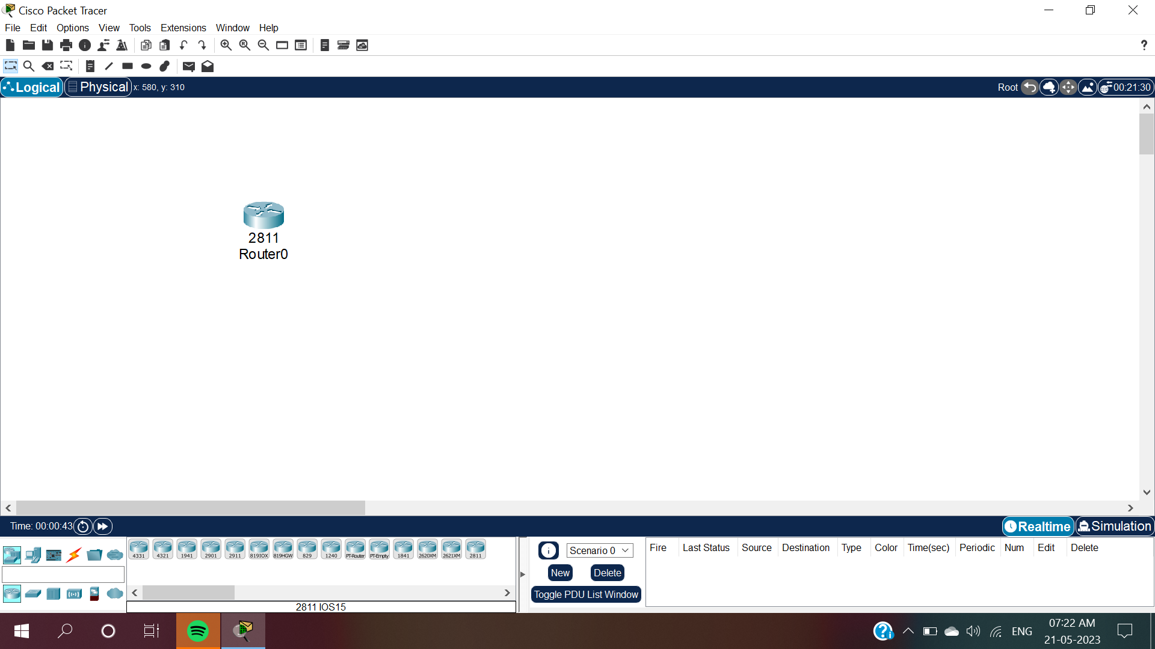

Fig.1:Open cisco packet tracer and click on Network Devices and Then click on routers and in routers select router 2811(Router0).

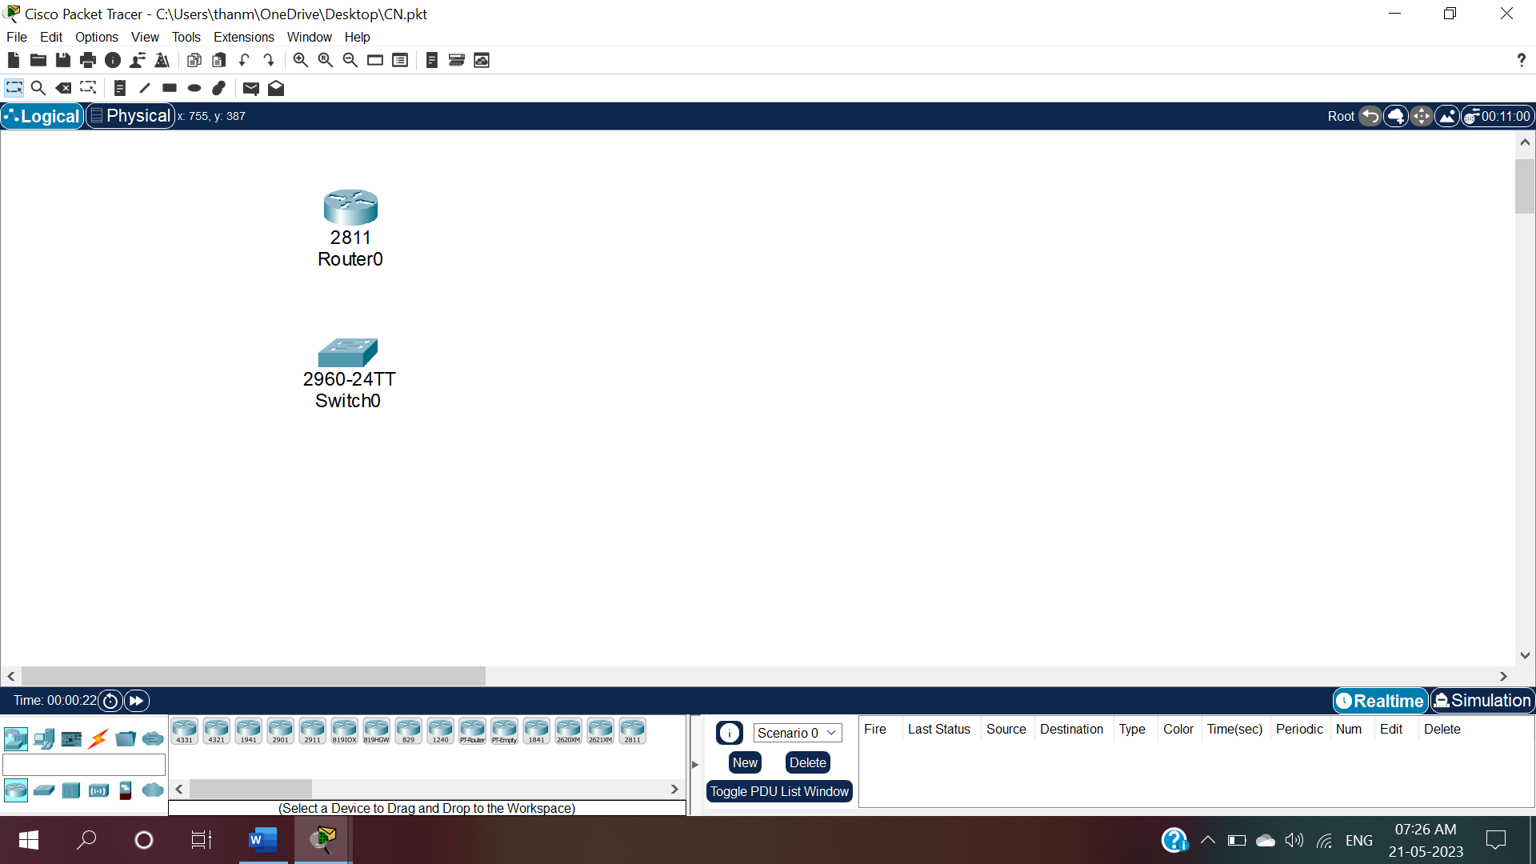

Fig.2:Now click on network devices and click on switches and then select 2960-24TT switch(Switch0).

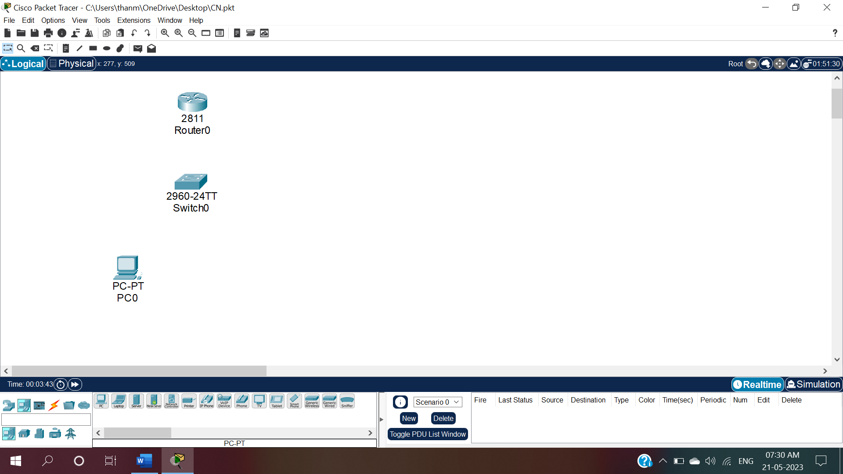

Fig.3:Now click on end devices and click on PC and select a PC-PT(PC0).

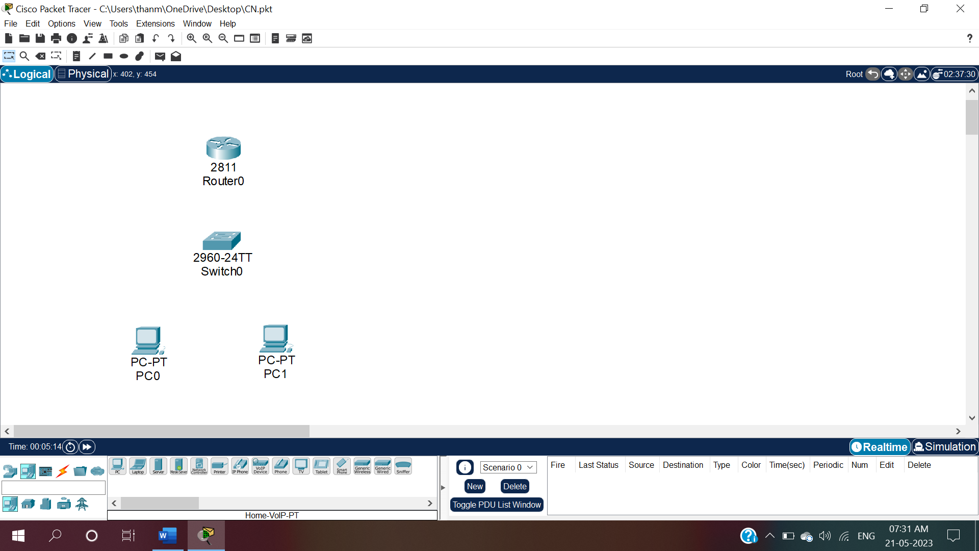

Fig.4:Now again click on end devices and click on PC and select another PC-PT(PC1).

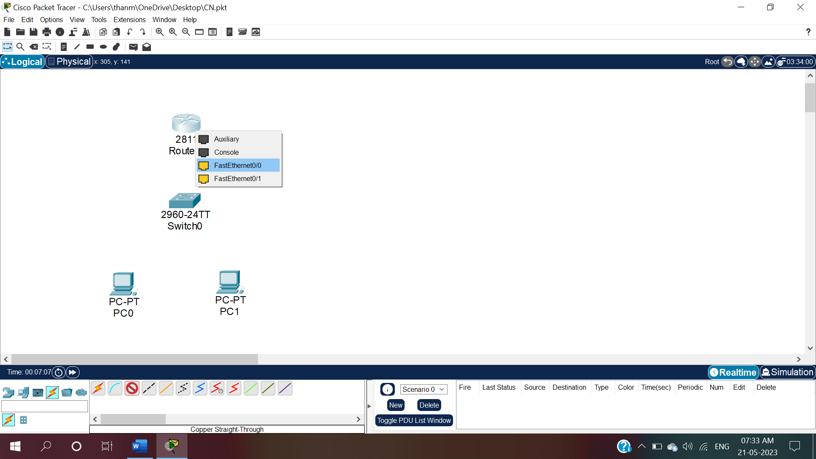

Fig.5:To give connections click on connections and then select copper straight through and then click on router(Router0) and select FastEthernet0.

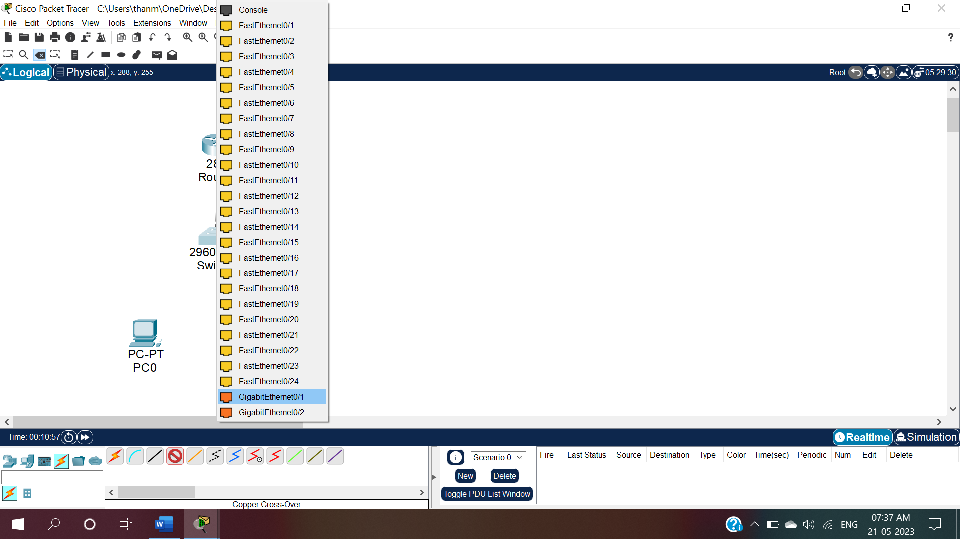

Fig.5.1:Drag the wire and click on switch0 and select GigaEthernet0/1.

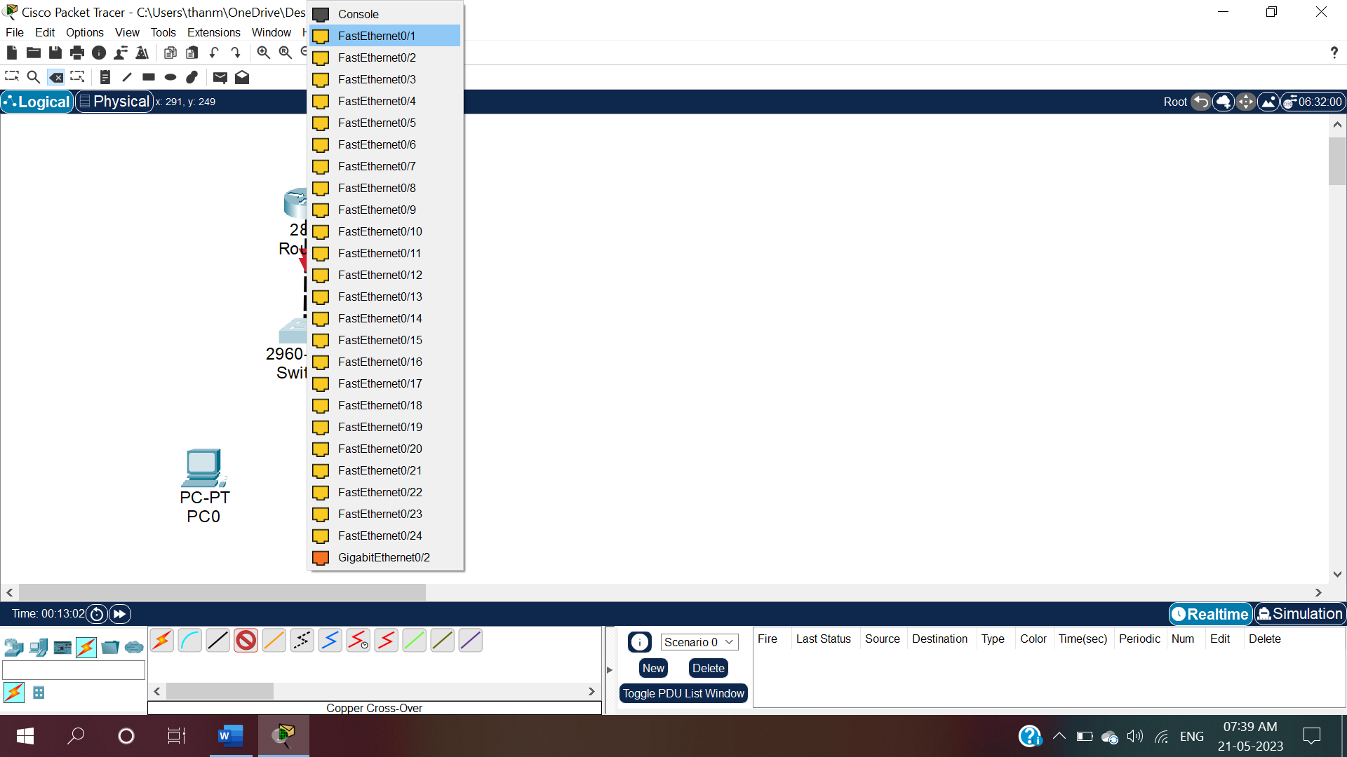

Fig 6:To connect switch0 and PC0 click on connections and select copper straight through and click on switch0 and select FastEthernet0/1.

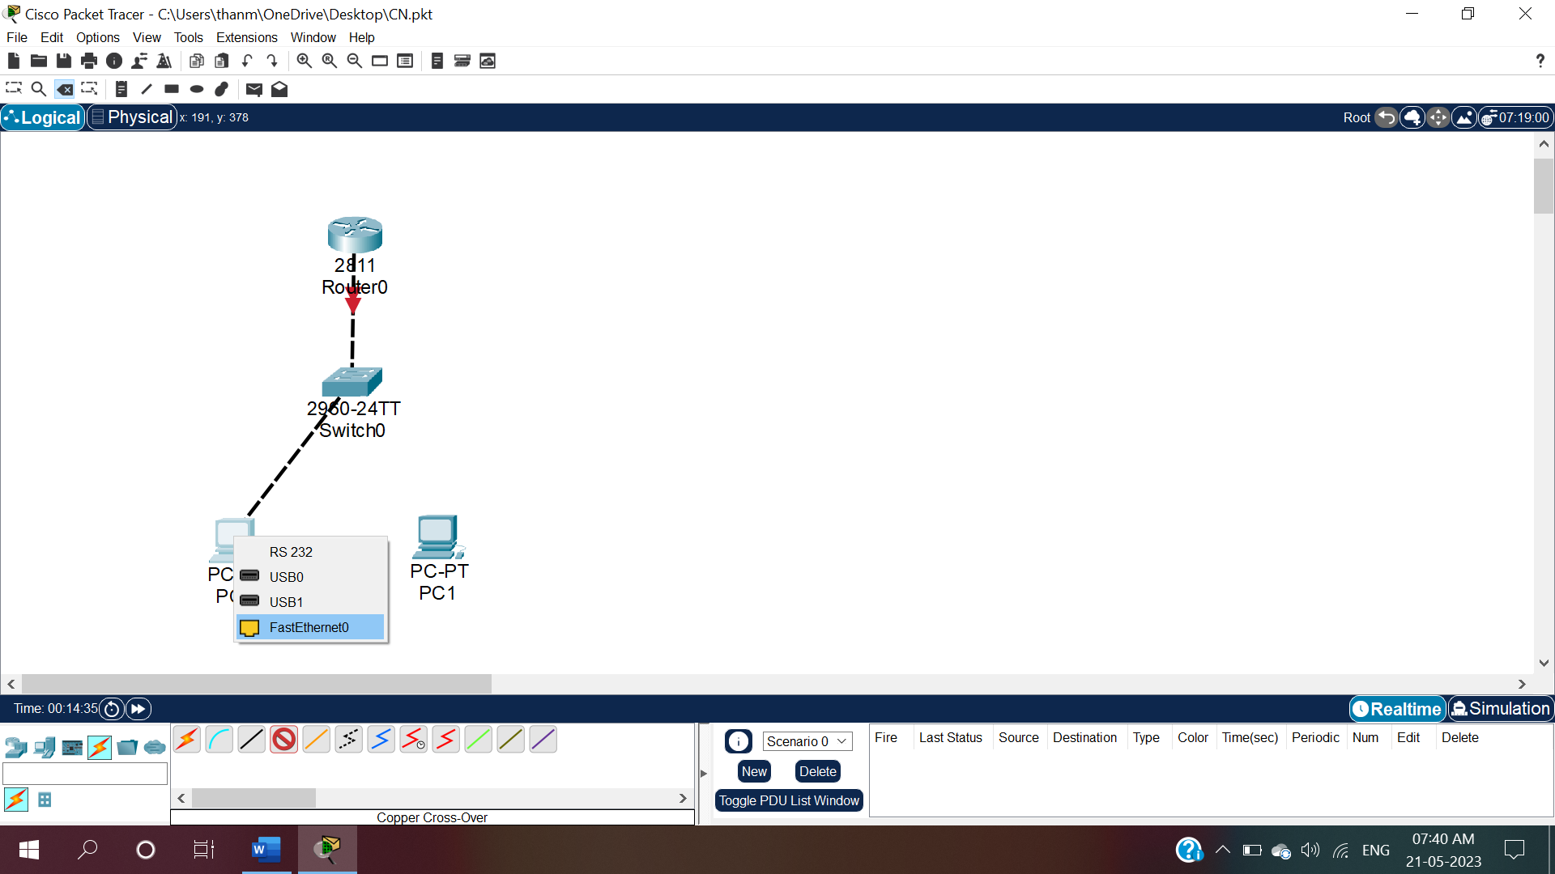

Fig.6.1: Drag the wire and click on PC0 and select FastEthernet0.

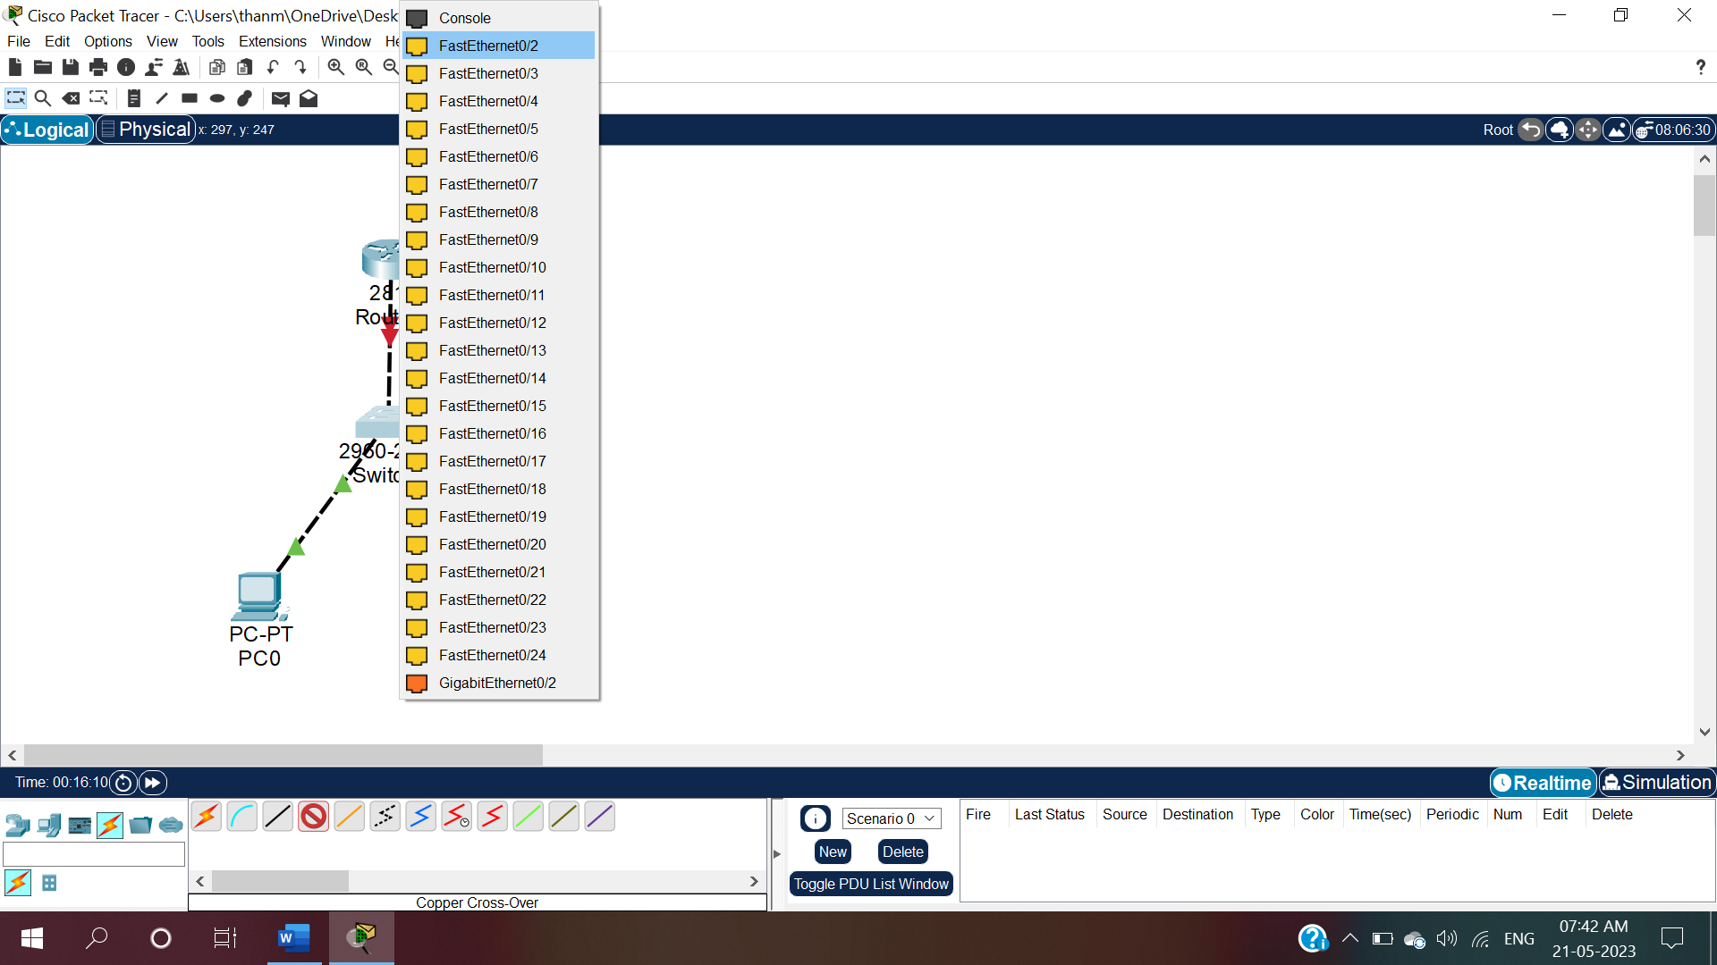

Fig .7:To connect switch0 and PC1 click on connections and select copper straight through and click on switch0 and select FastEthernet0/2.

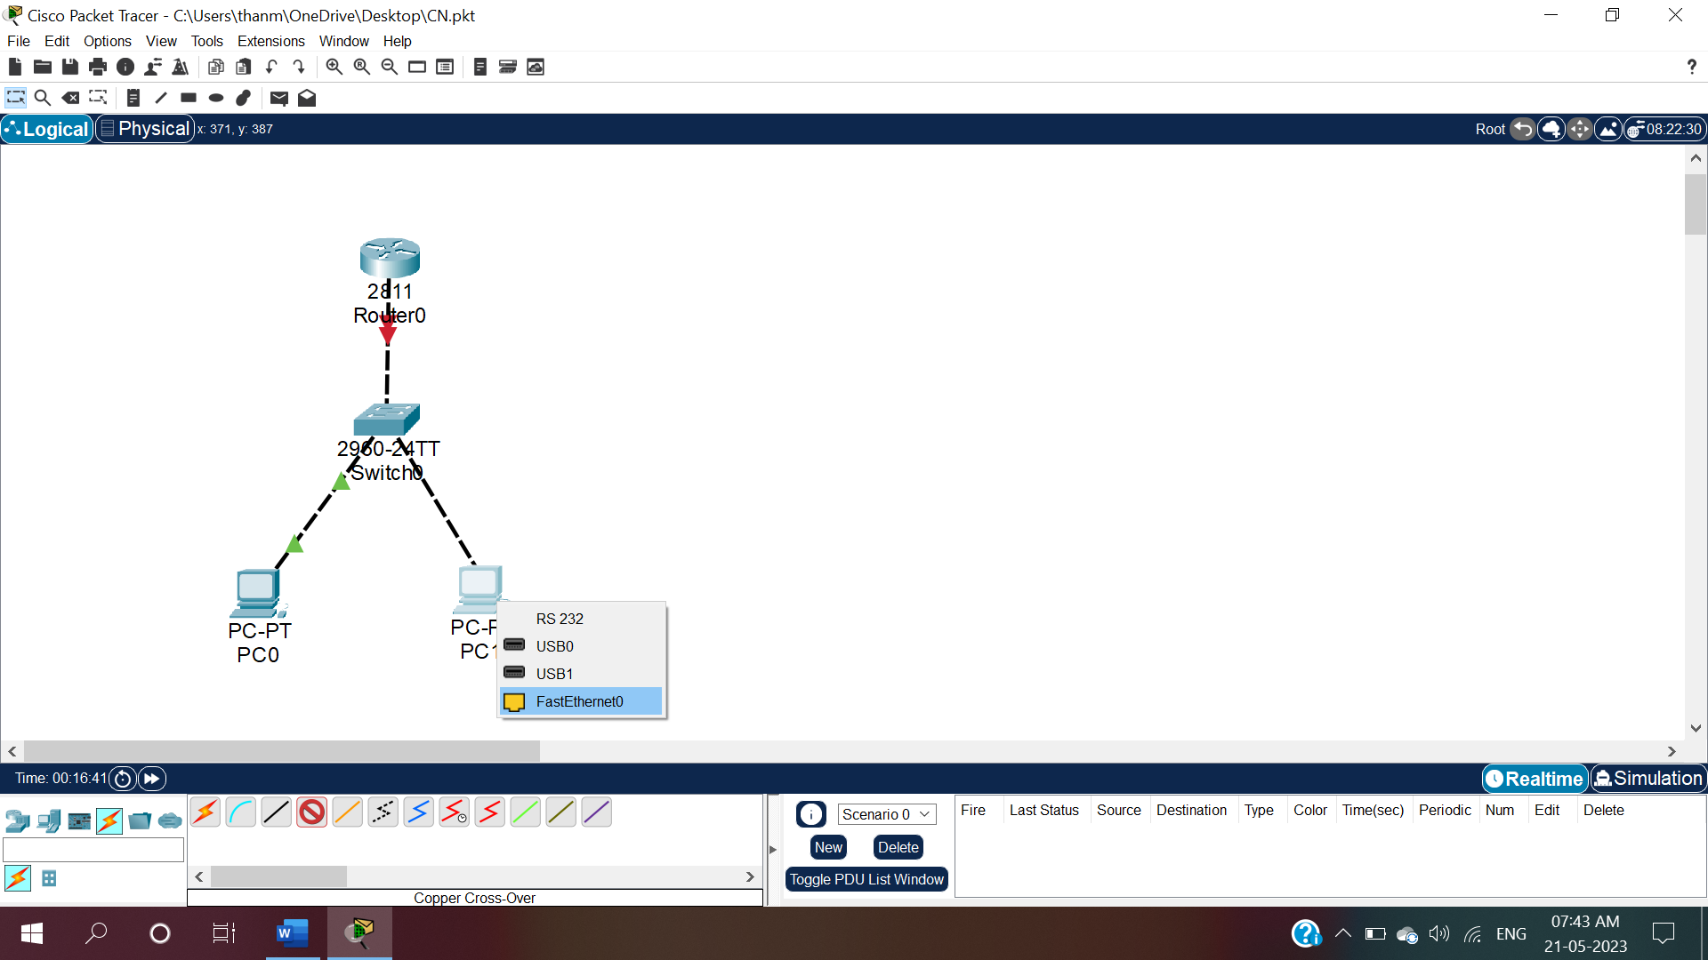

Fig.7.1: Drag the wire and click on PC1 and select FastEthernet0.

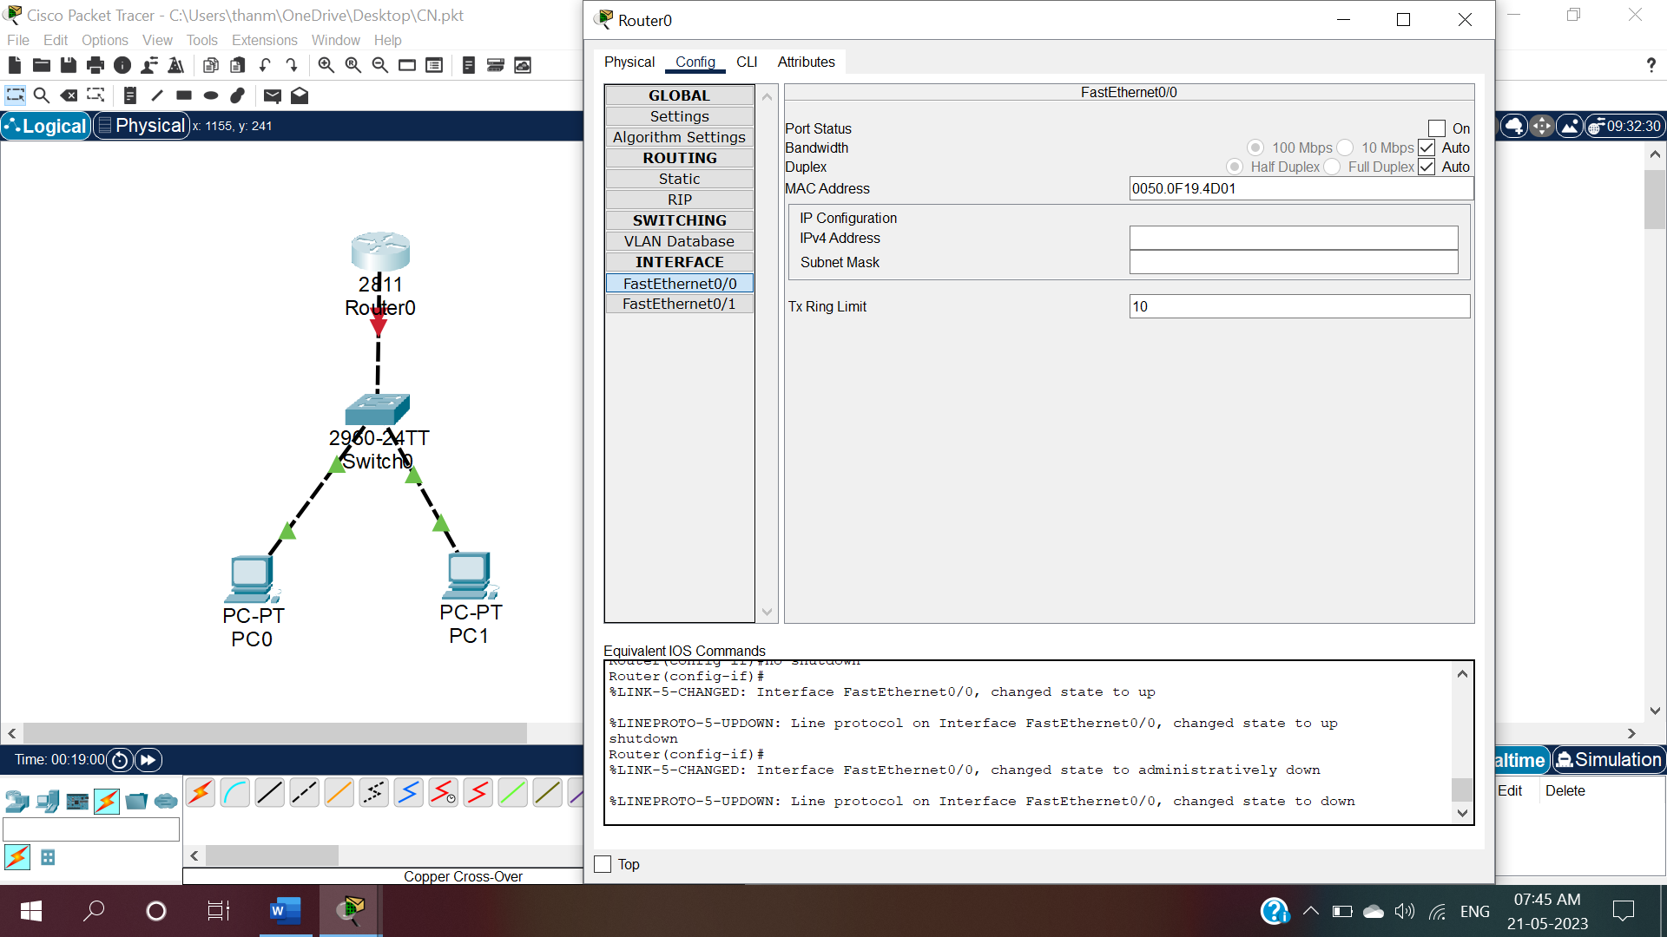

Fig.8:To give IP configuration for Router0 ,click on Router0 and select config window.

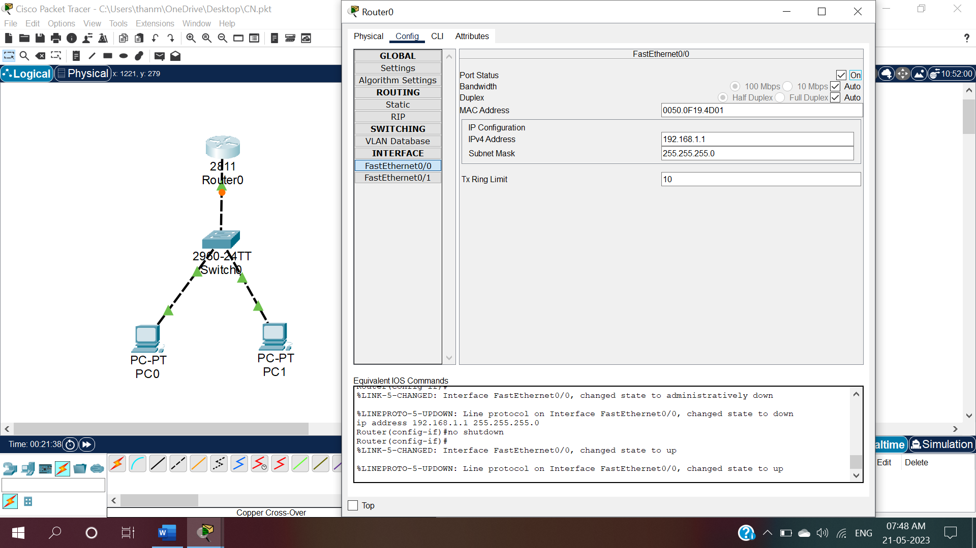

Fig.8.1:In that config window, give IP configuration as 192.168.1.1 and ON the Router0.

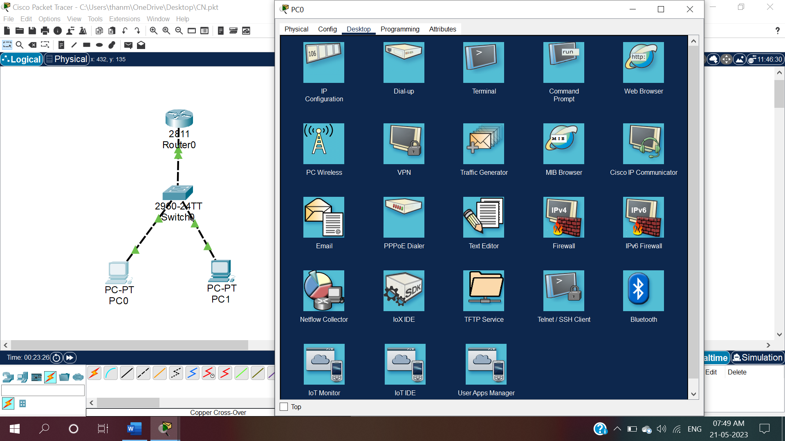

Fig.9:To give IP configuration for PC0 click on PC0 and then under Desktop, select IP configuration.

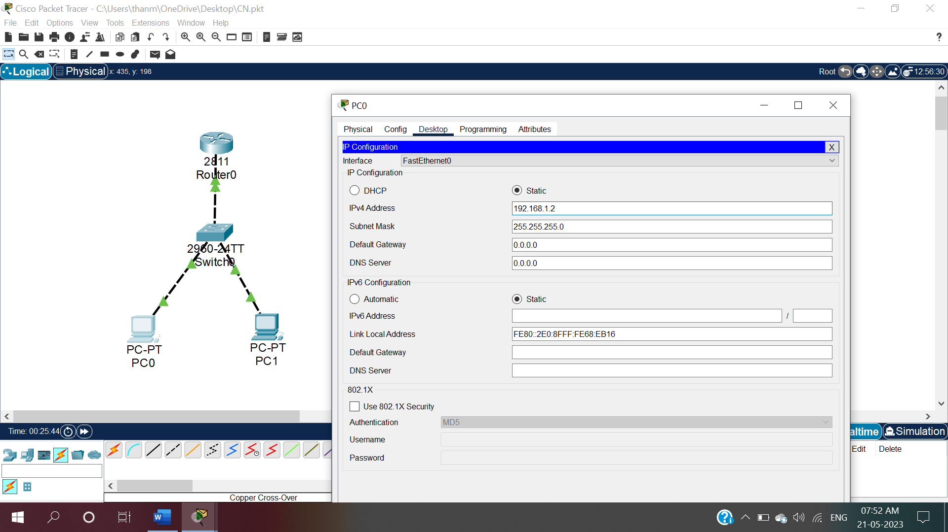

Fig.9.1:Give IPv4 address for PC0 as 192.168.1.2 and click enter.

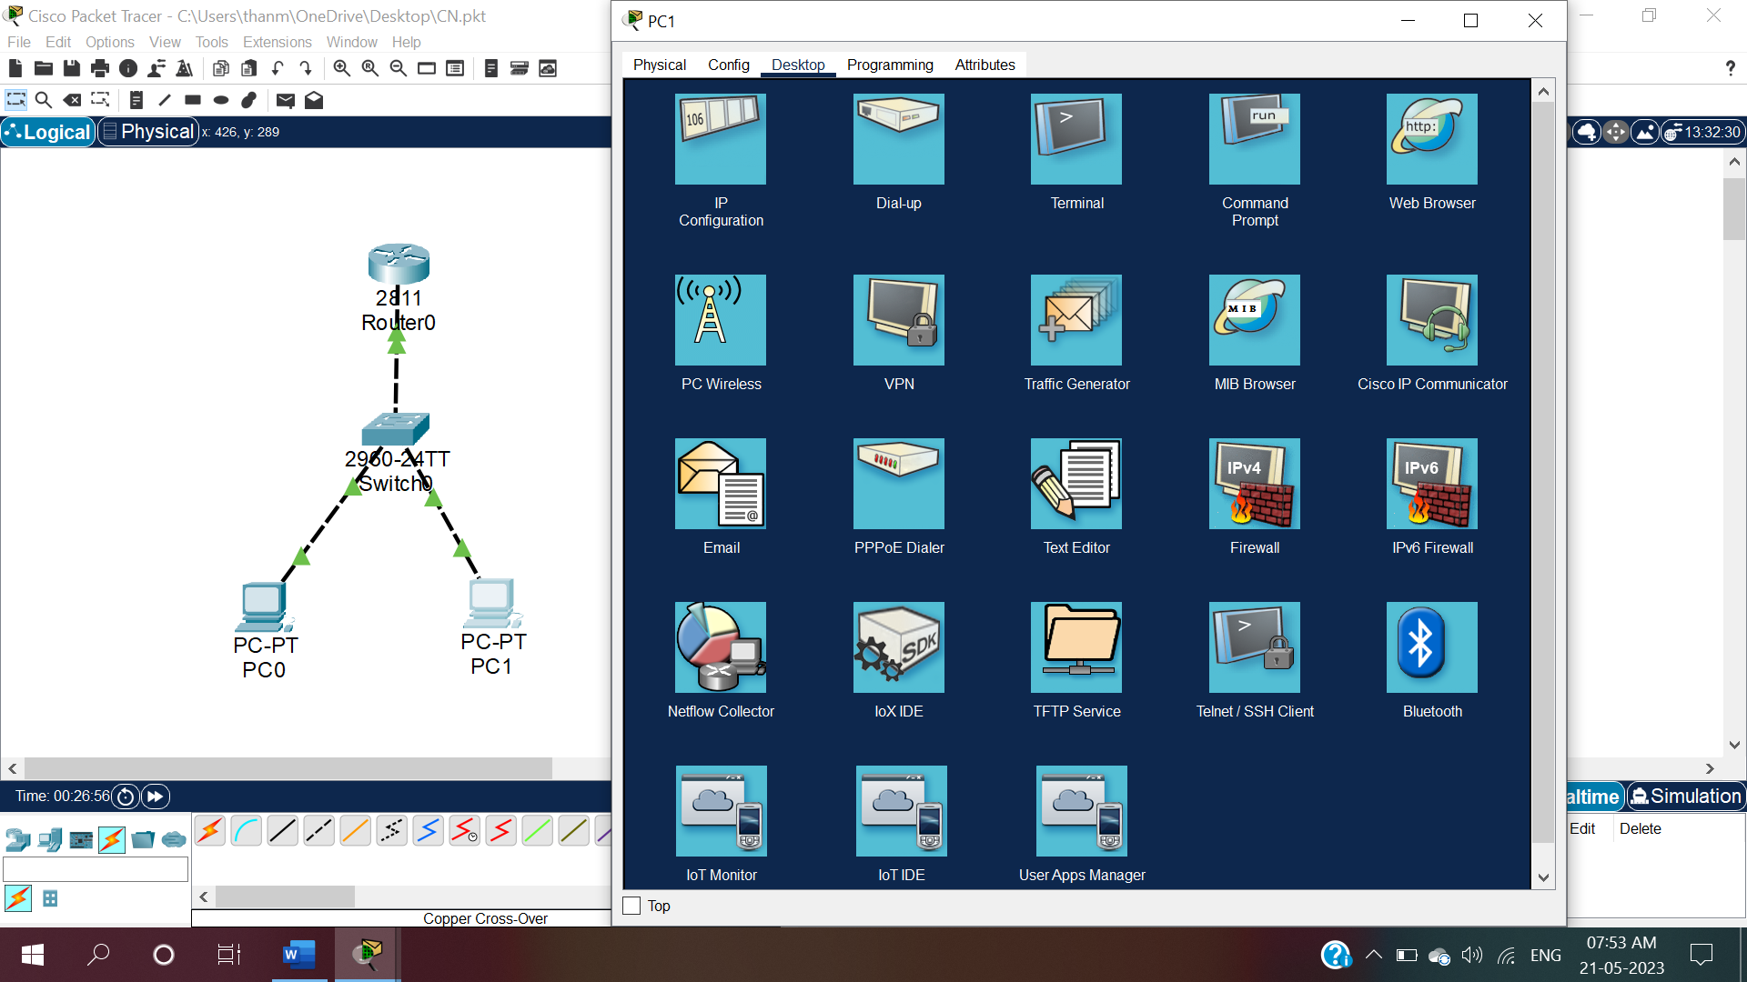

Fig.10:To give IP configuration for PC1 click on PC1 and then under Desktop, select IP configuration

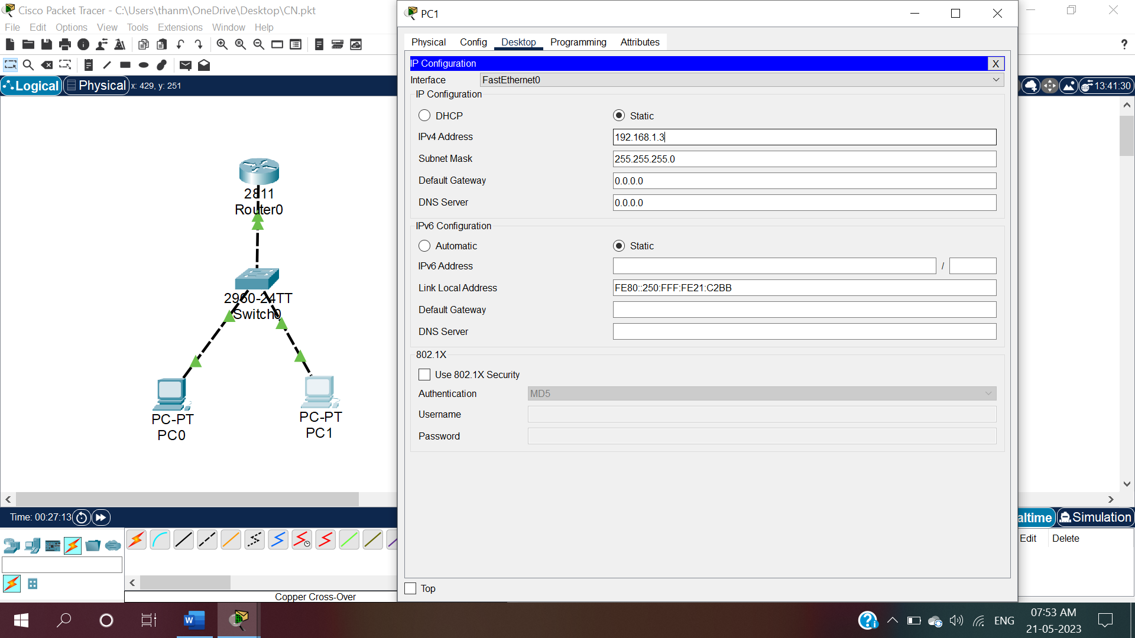

Fig.9.1:Give IPv4 address for PC1 as 192.168.1.3 and click enter.

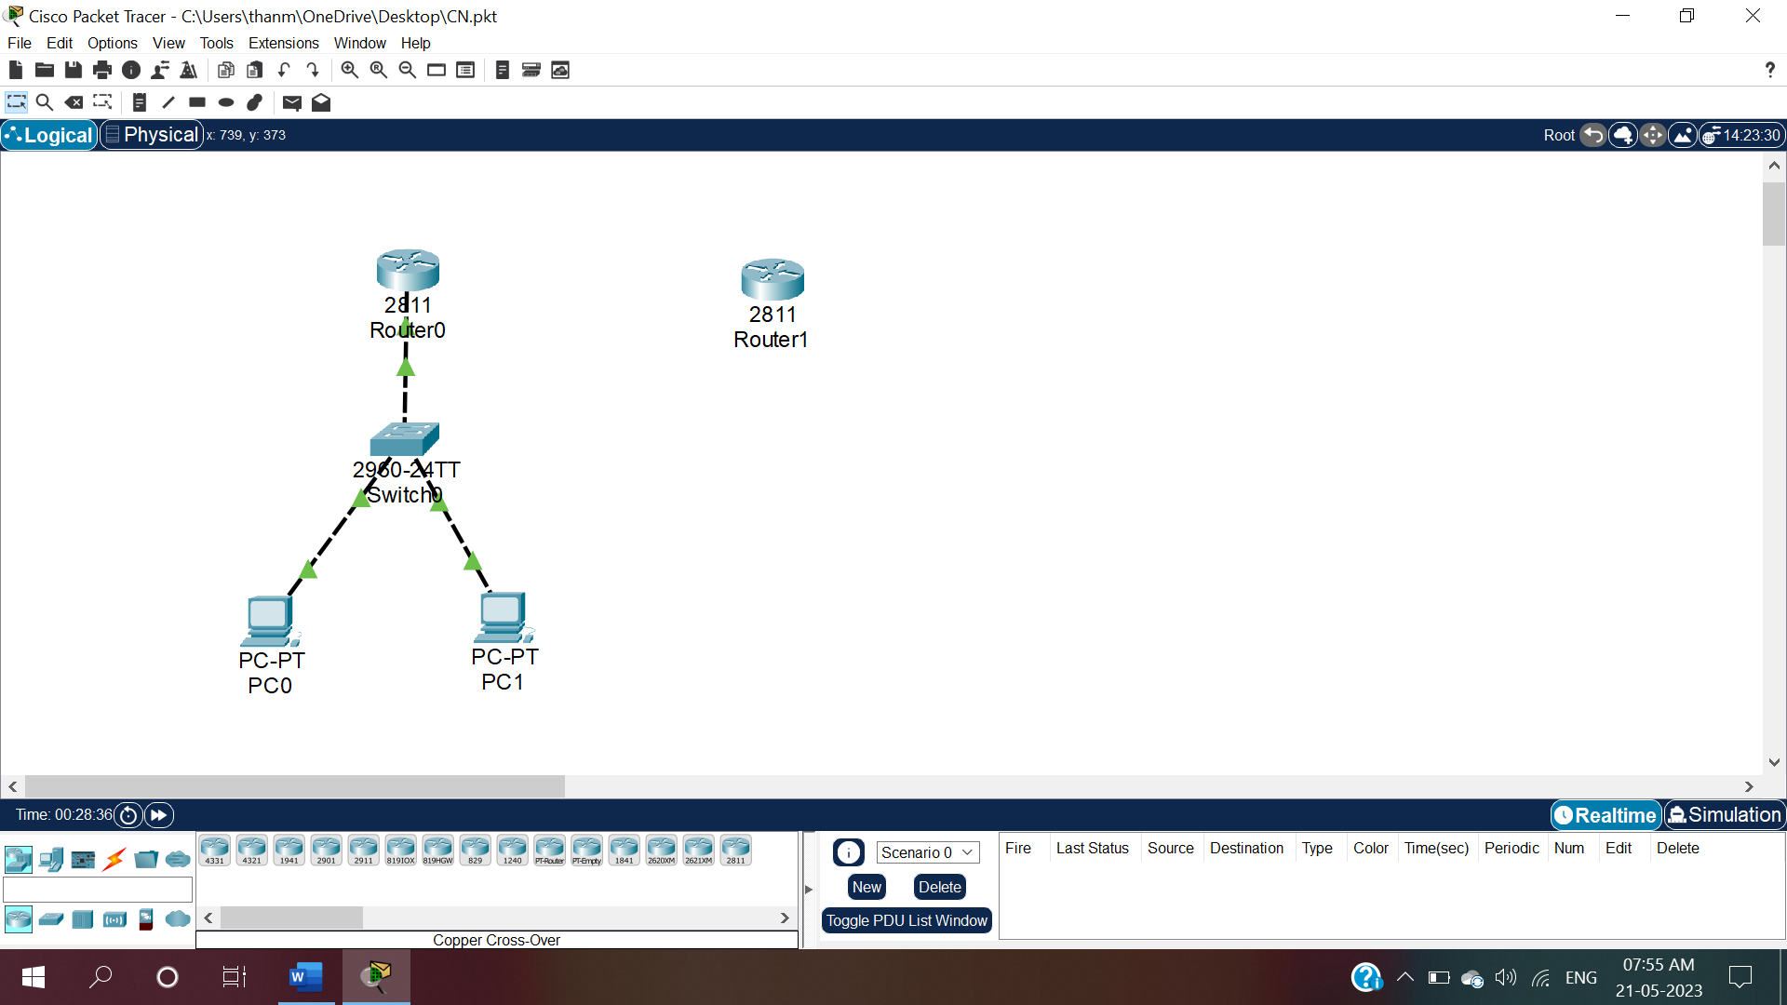

Fig.10:Click on Network Devices and Then click on routers and in routers select router 2811(Router1).

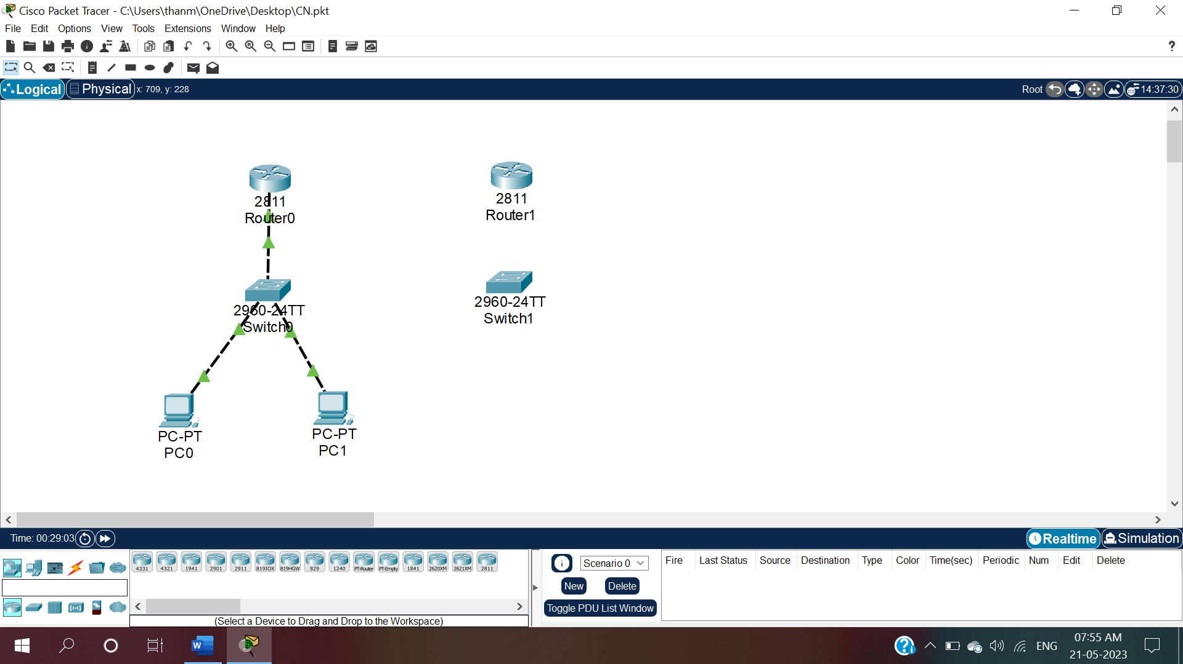

Fig.11:Now click on network devices and click on switches and then select 2960-24TT switch(Switch1).

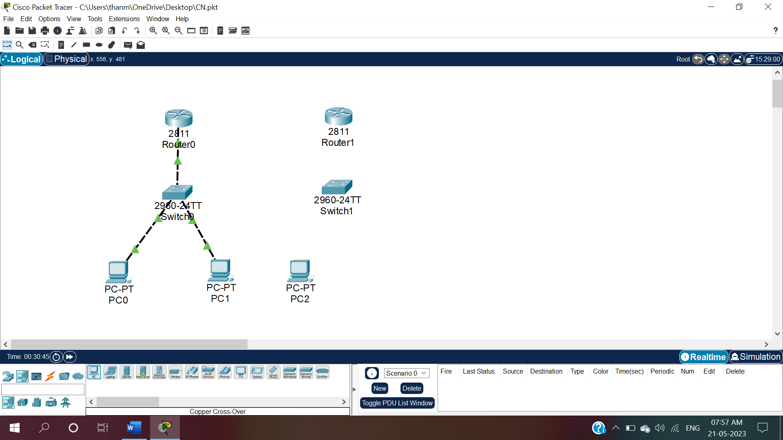

Fig.12:Now click on end devices and click on PC and select a PC-PT(PC2).

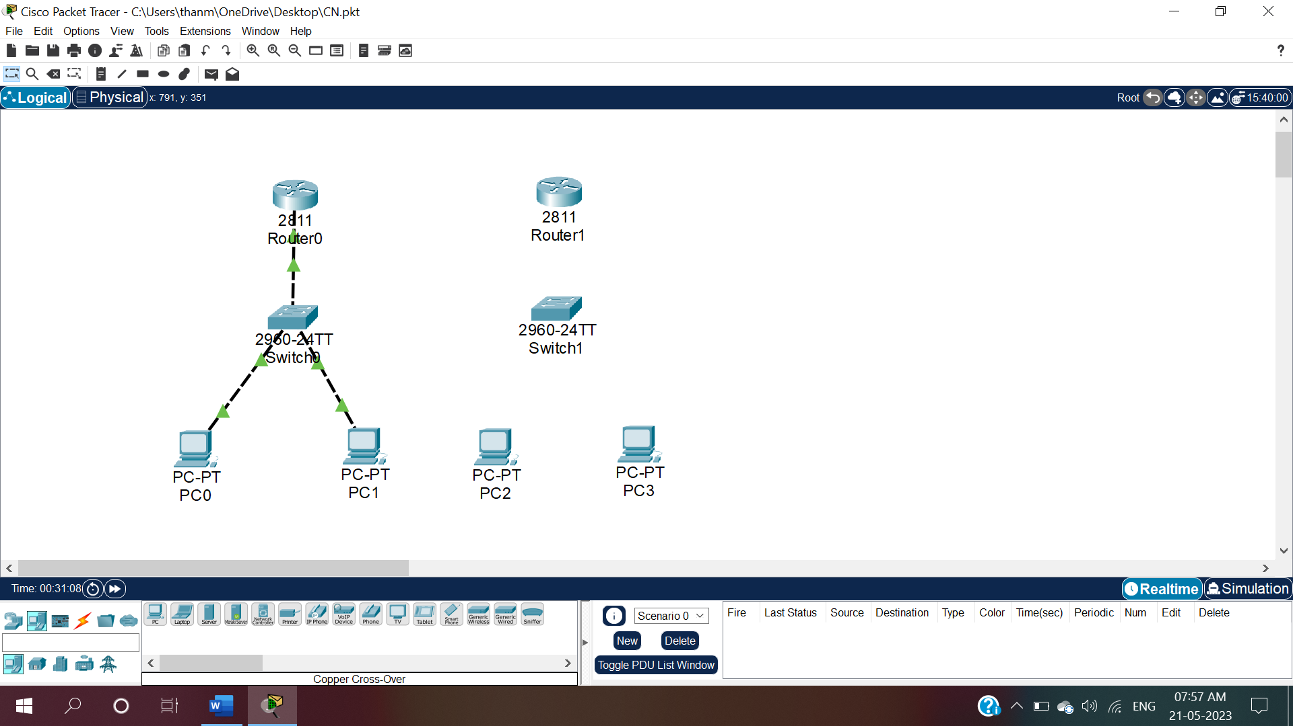

Fig.13:Now click on end devices and click on PC and select another PC-PT(PC3).

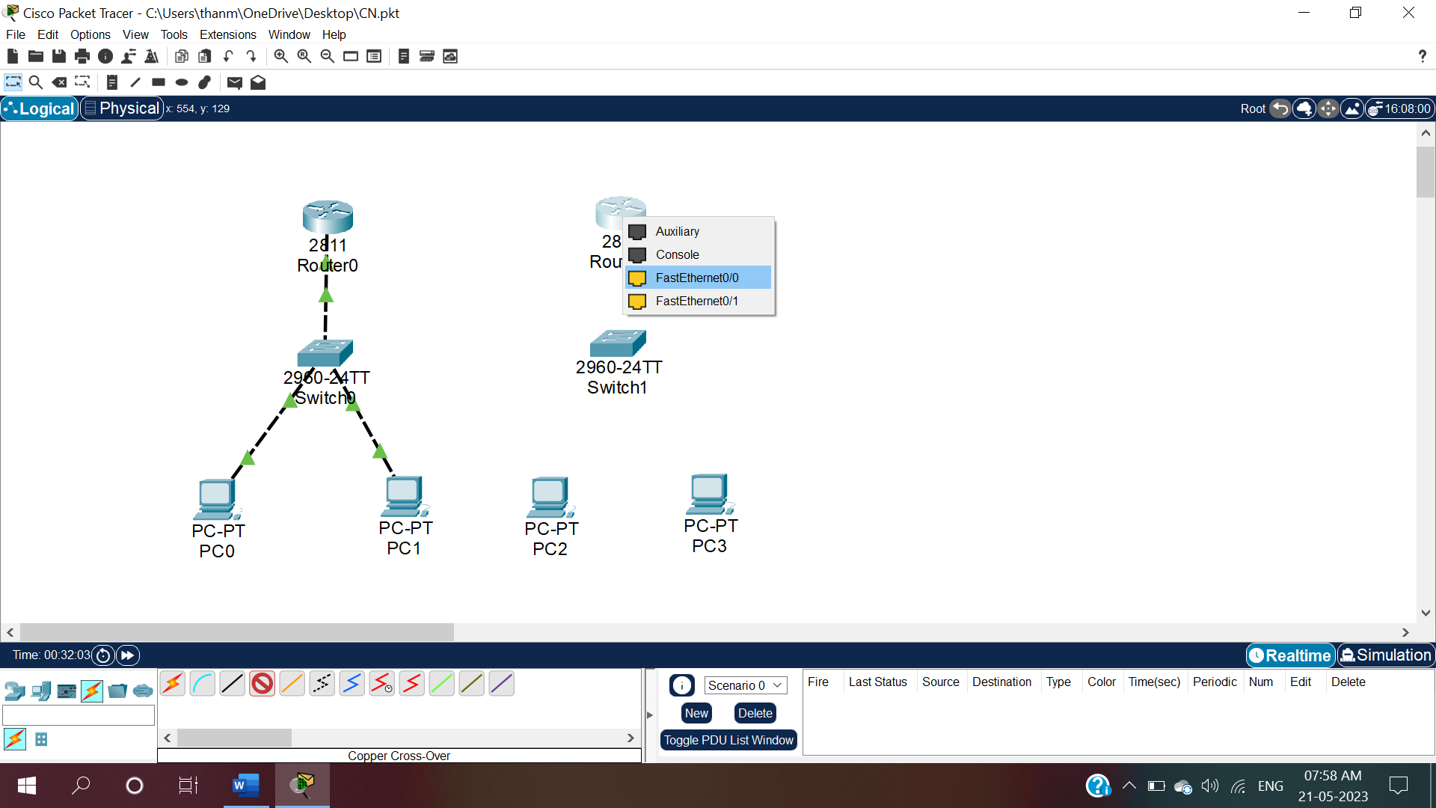

Fig.14:To give connections click on connections and then select copper straight through and then click on router(Router1) and select FastEthernet0.

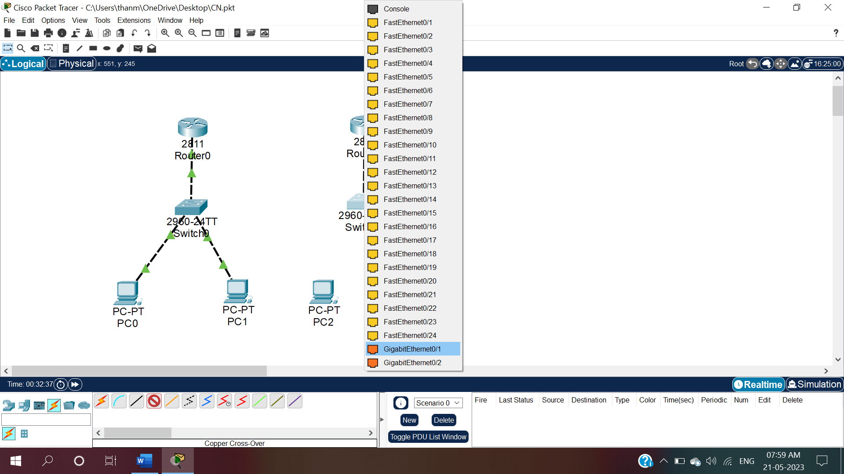

Fig.14.1:Drag the wire and click on switch1 and select GigaEthernet0/1.

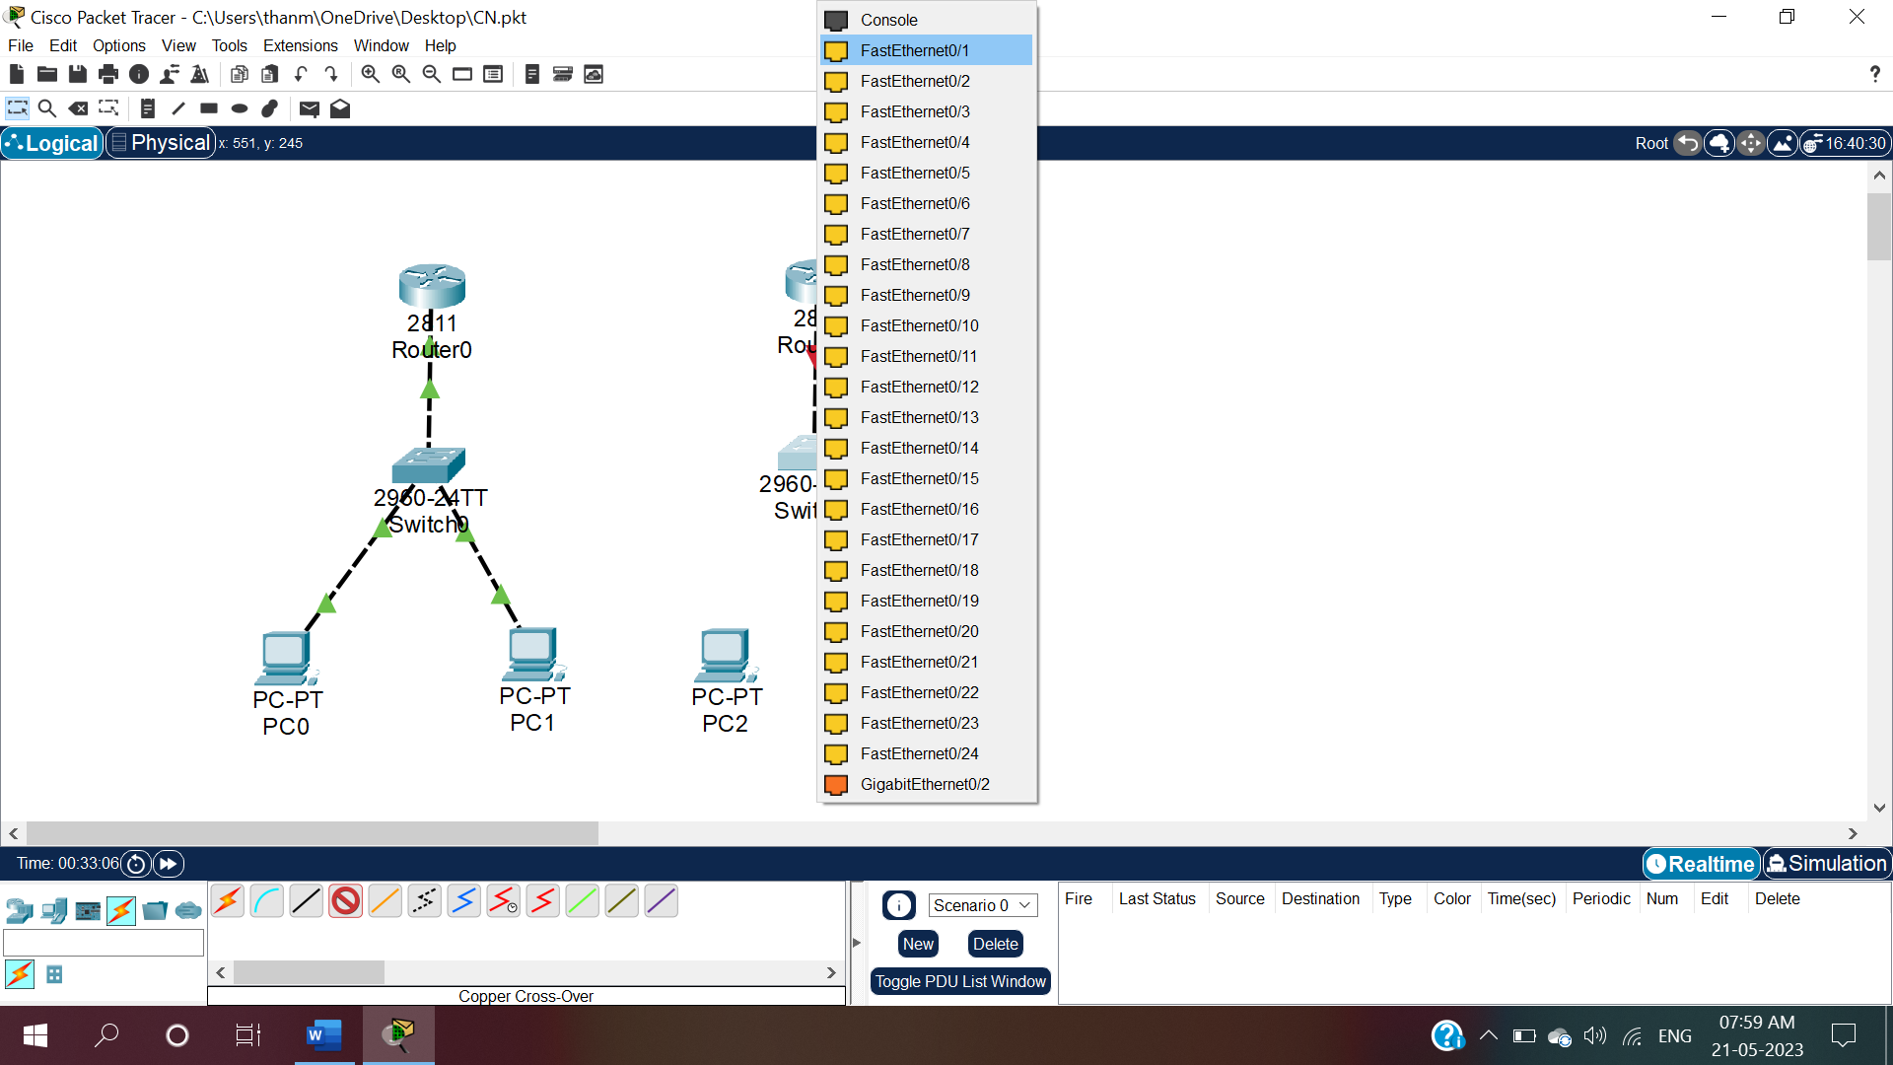

Fig 15:To connect switch1 and PC2 click on connections and select copper straight through and click on switch1 and select FastEthernet0/1.

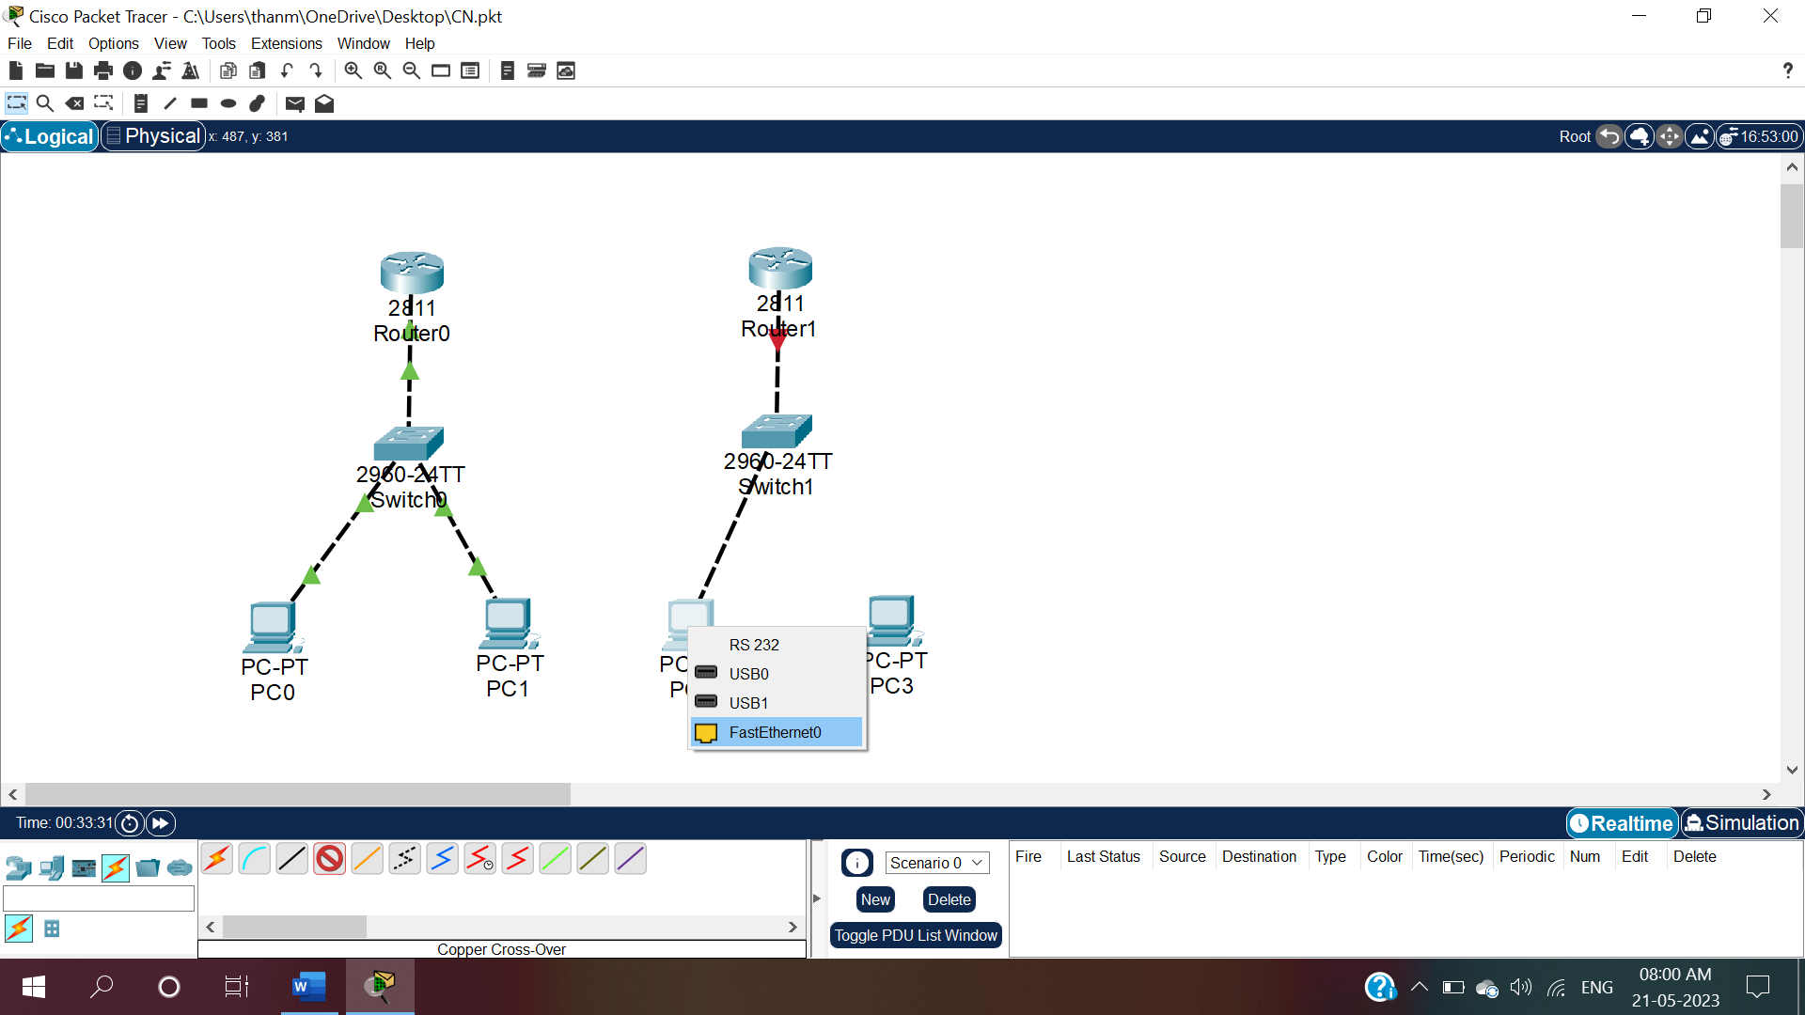

Fig.15.1: Drag the wire and click on PC2 and select FastEthernet0.

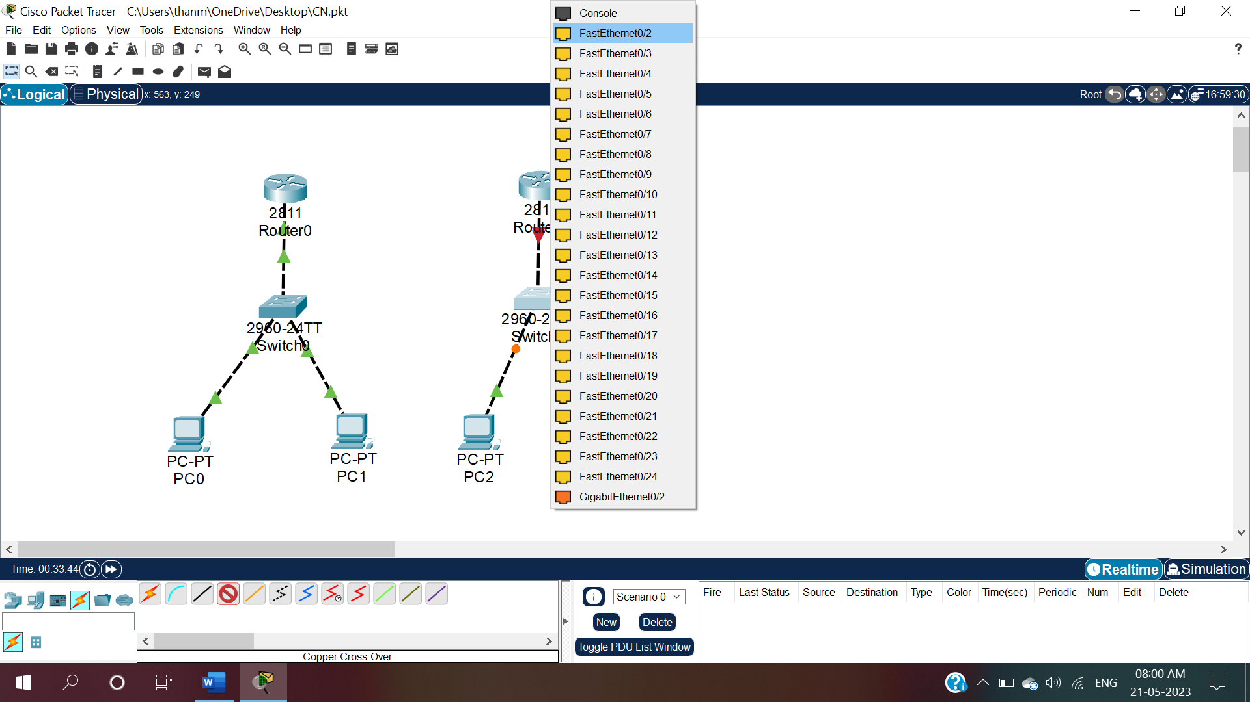

Fig .16:To connect switch1 and PC3 click on connections and select copper straight through and click on switch1 and select FastEthernet0/2.

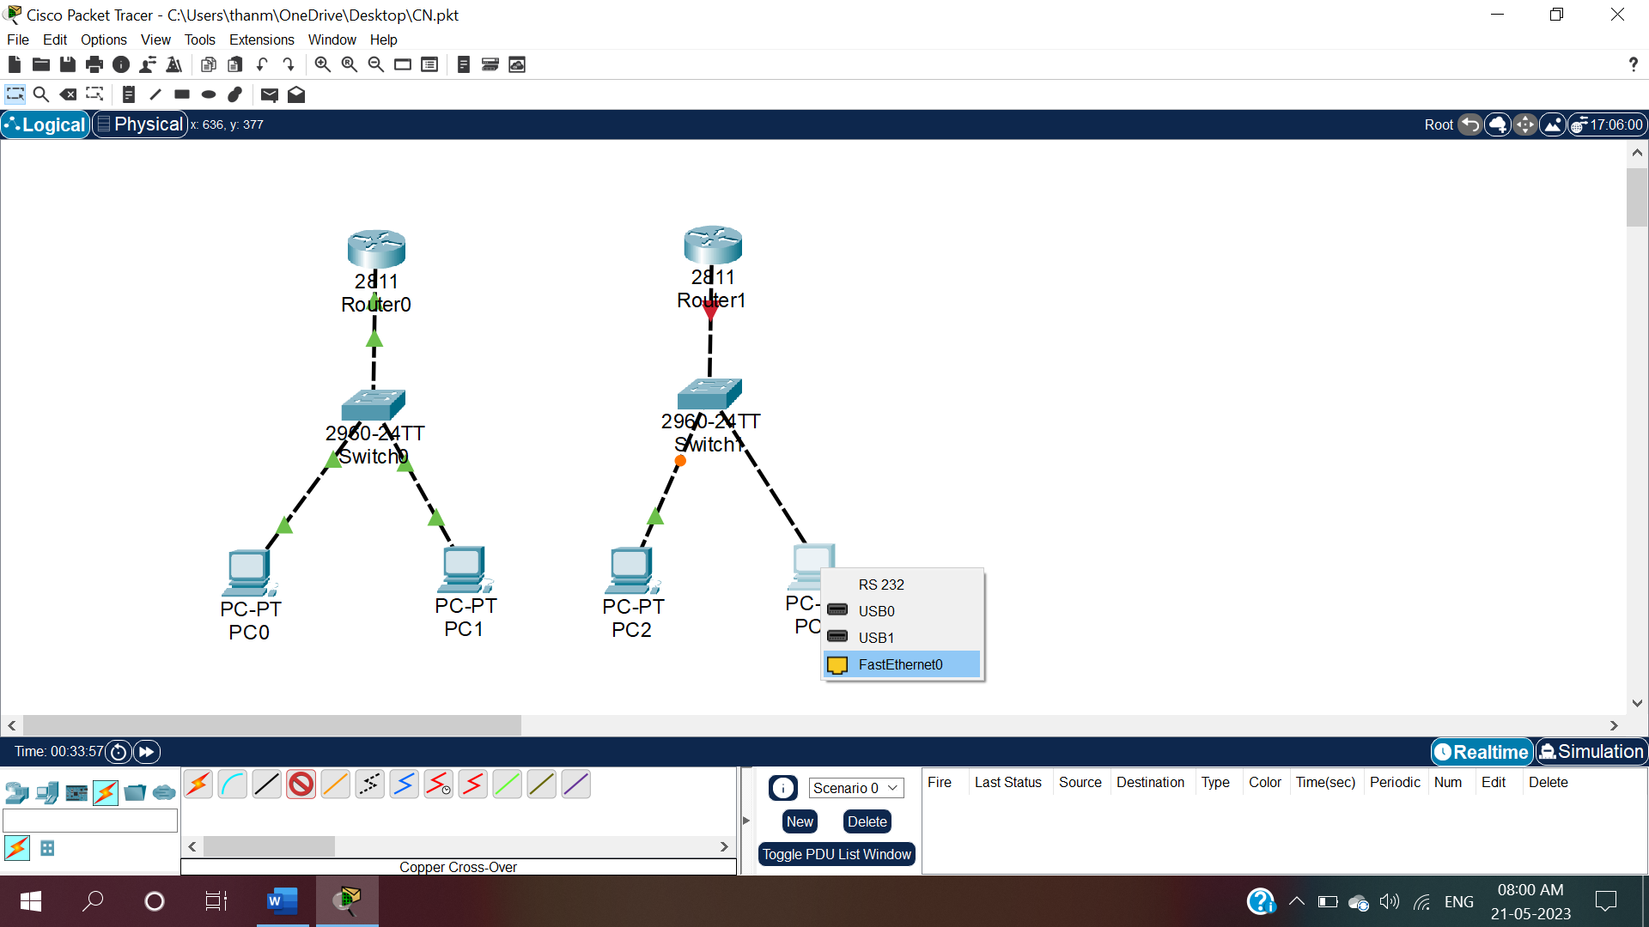

Fig.16.1: Drag the wire and click on PC3 and select FastEthernet0.

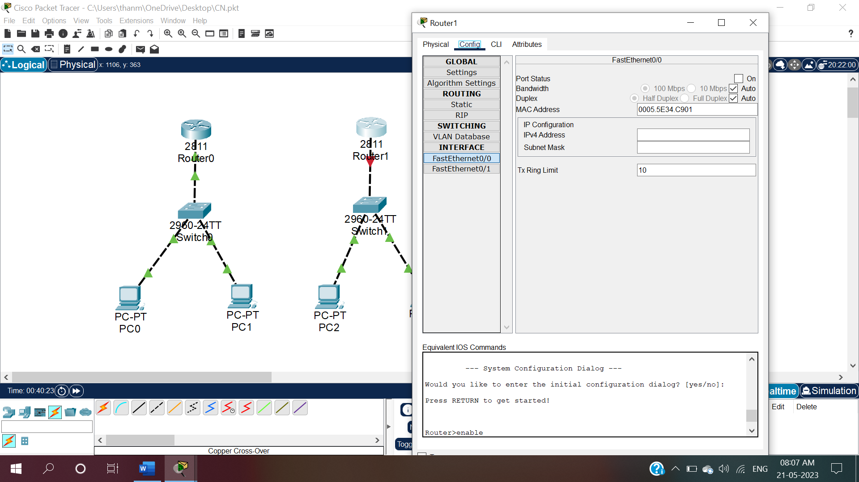

Fig.17:To give IP configuration for Router1 ,click on Router1 and select config window.

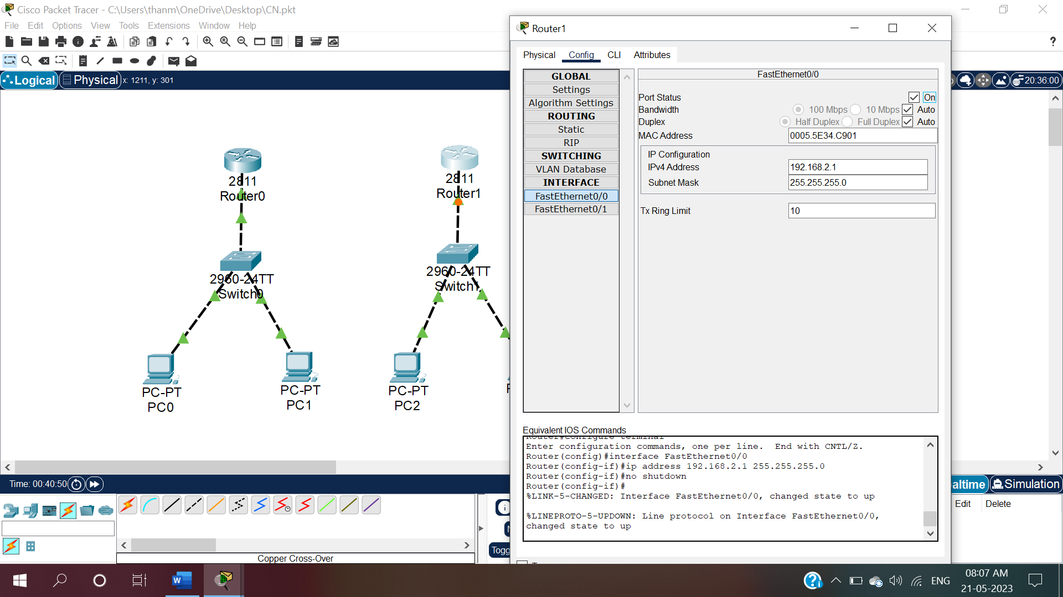

Fig.17.1:In that config window, give IP configuration as 192.168.2.1 and ON the Router1.

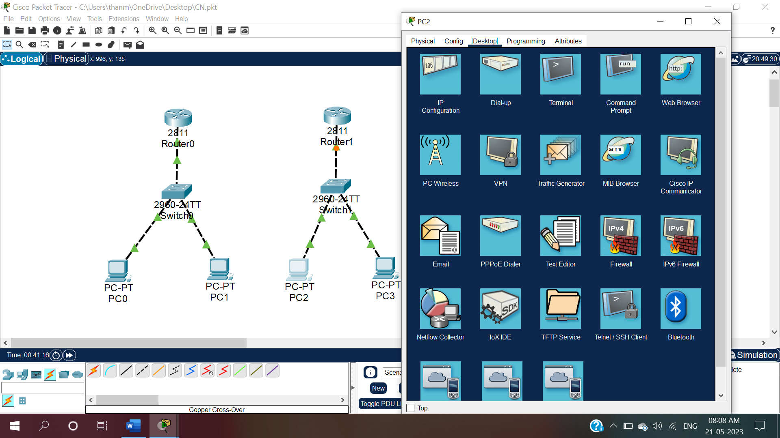

Fig.18:To give IP configuration for PC2 click on PC2 and then under Desktop, select IP configuration

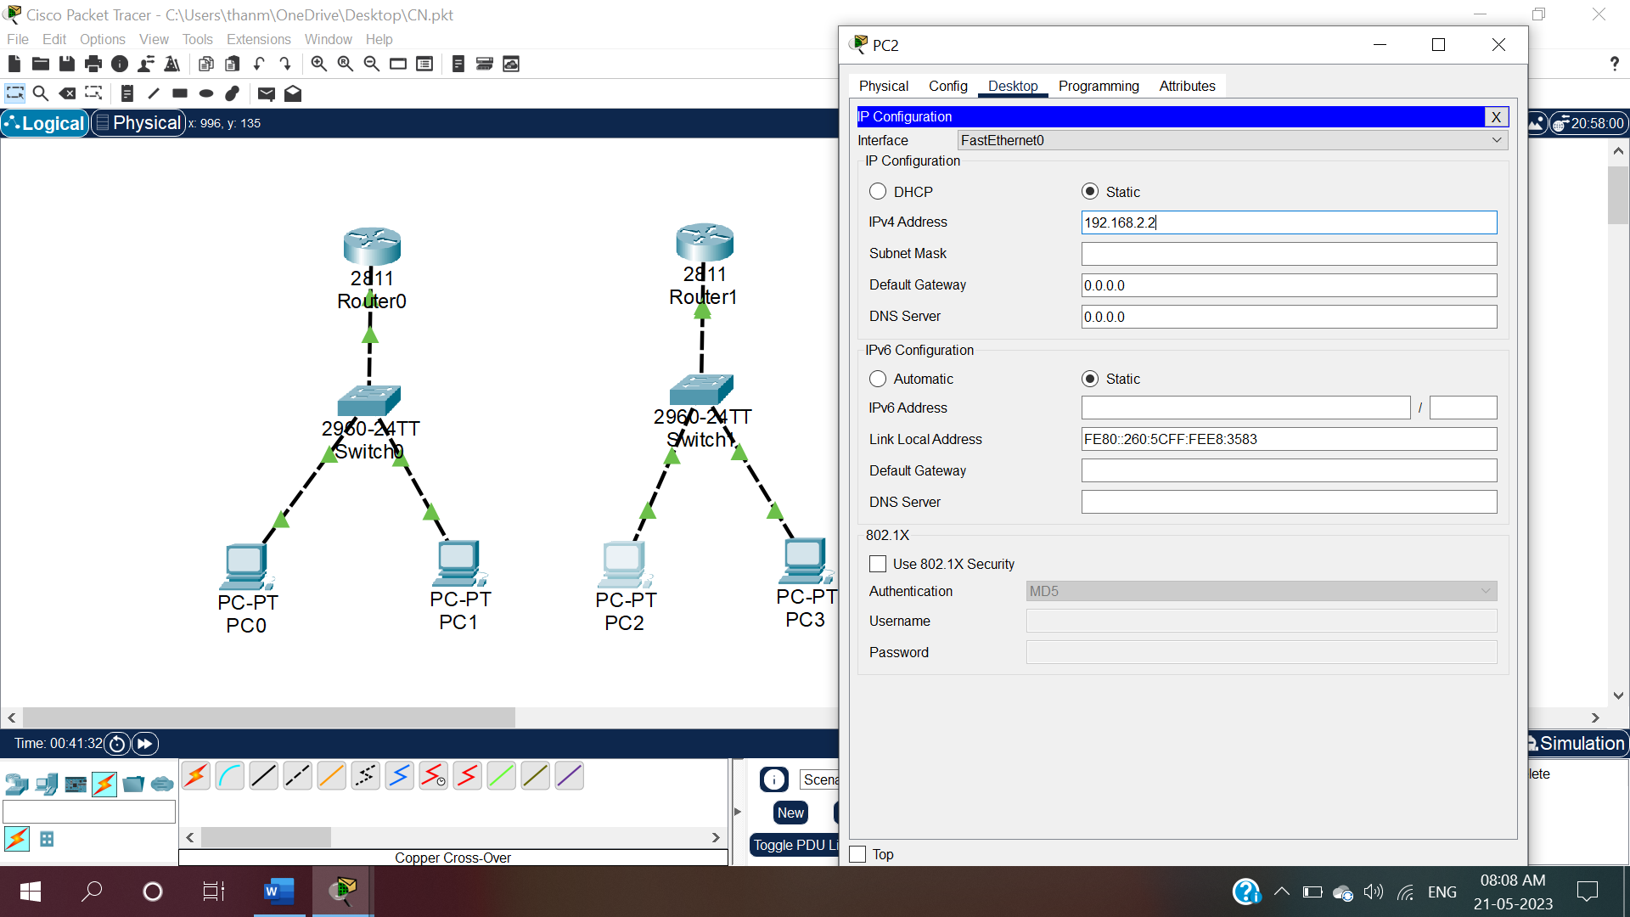

Fig.18.1:Give IPv4 address for PC2 as 192.168.2.3 and click enter.

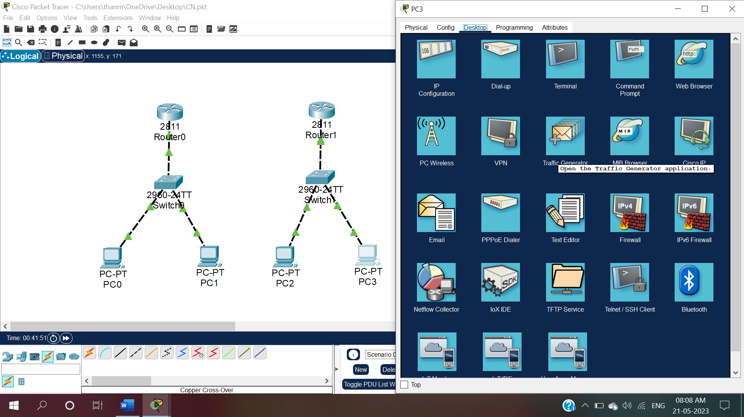

Fig.19:To give IP configuration for PC3 click on PC3 and then under Desktop, select IP configuration

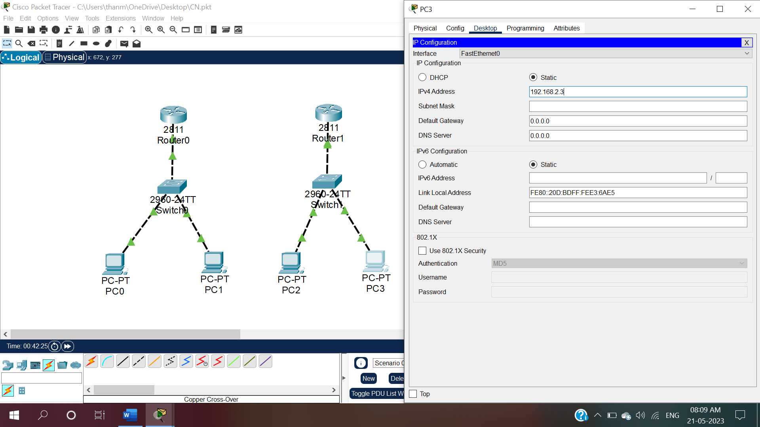

Fig.19.1:Give IPv4 address for PC3 as 192.168.2.3 and click enter.

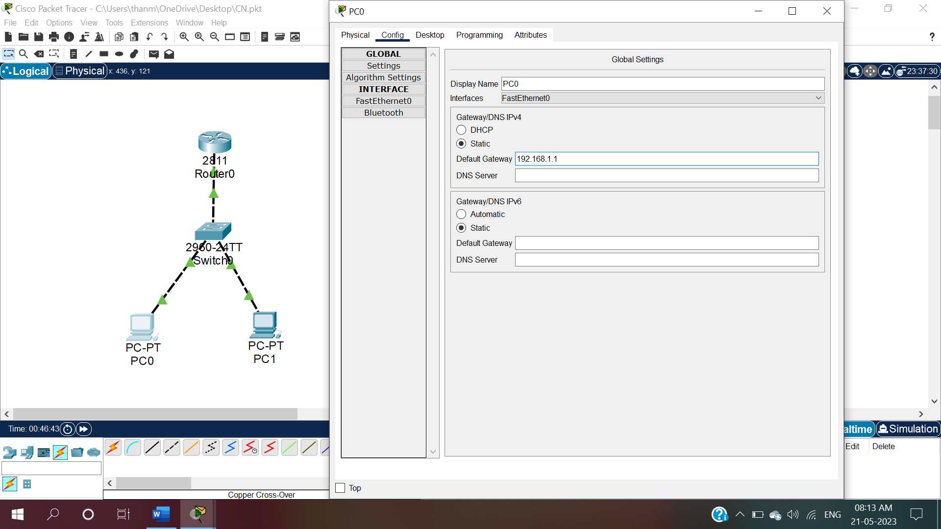

Fig.20:To give default gateway values for PC0, click on PC0 and select config and give default gateway address as 192.168.1.1

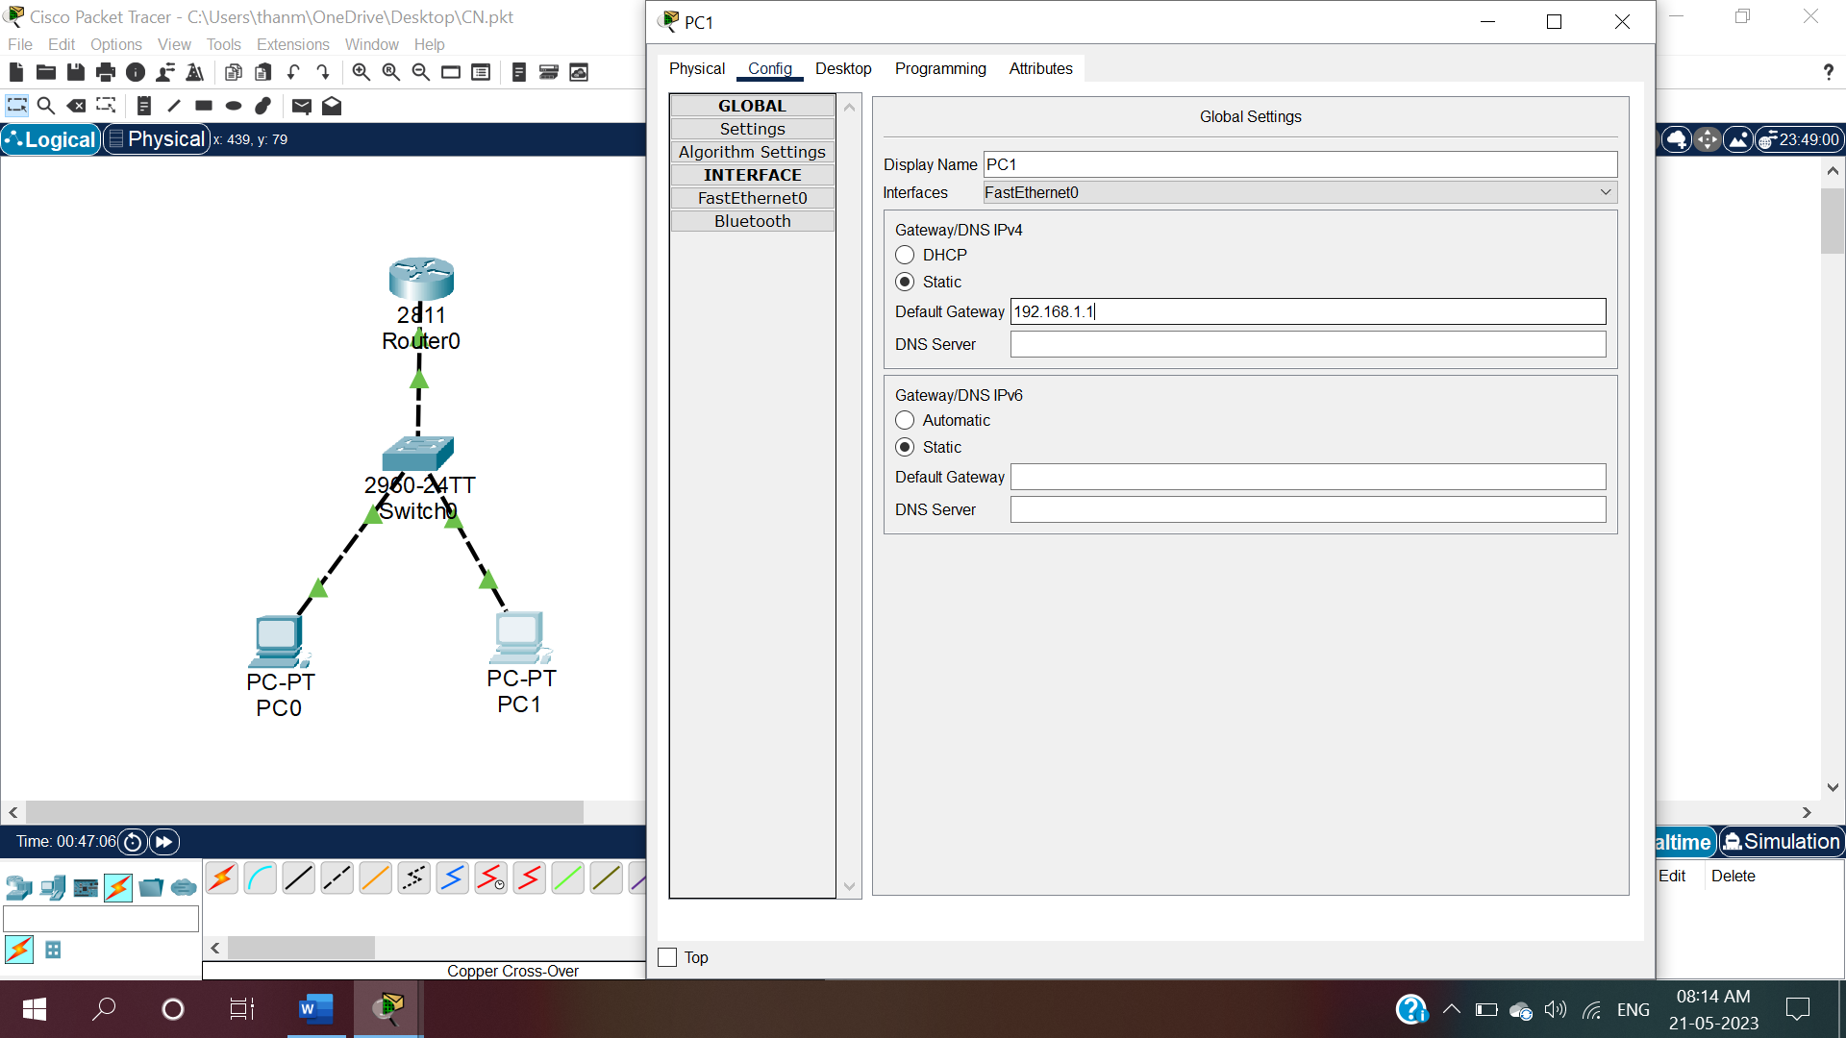

Fig.21:To give default gateway values for PC1, click on PC1 and select config and give default gateway address as 192.168.1.1

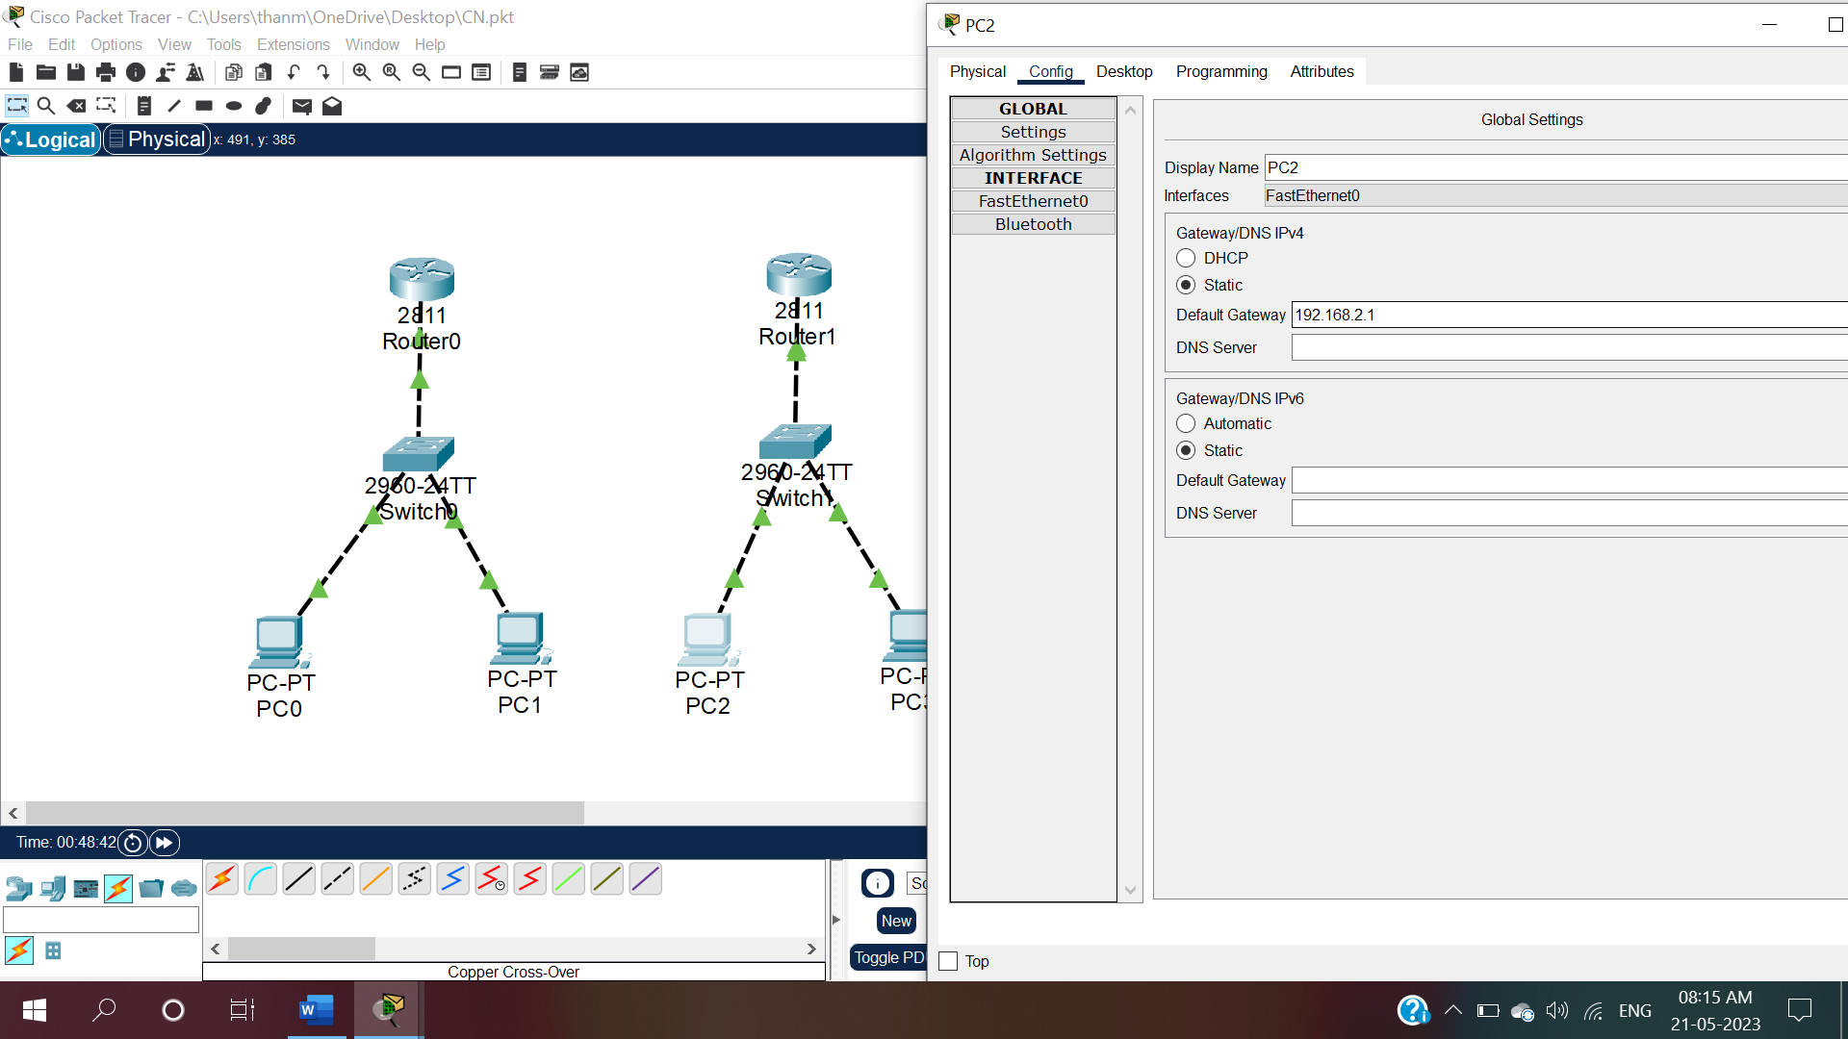

Fig.22:To give default gateway values for PC2, click on PC2 and select config and give default gateway address as 192.168.2.1

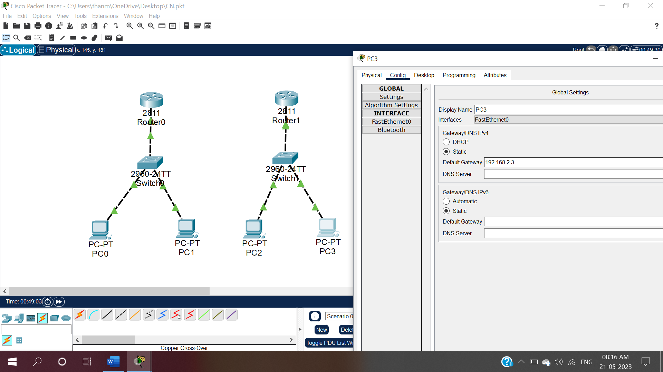

Fig.21:To give default gateway values for PC3, click on PC3 and select config and give default gateway address as 192.168.2.1

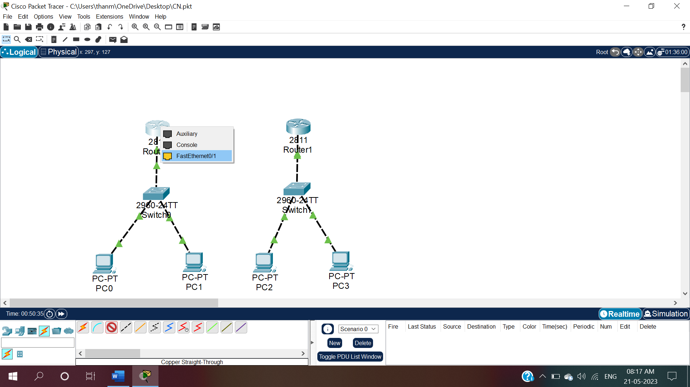

Fig.22:To connect Router0 and Router1, click on connections and select copper cross over and then click on Router0 and select FastEthernet0/1.

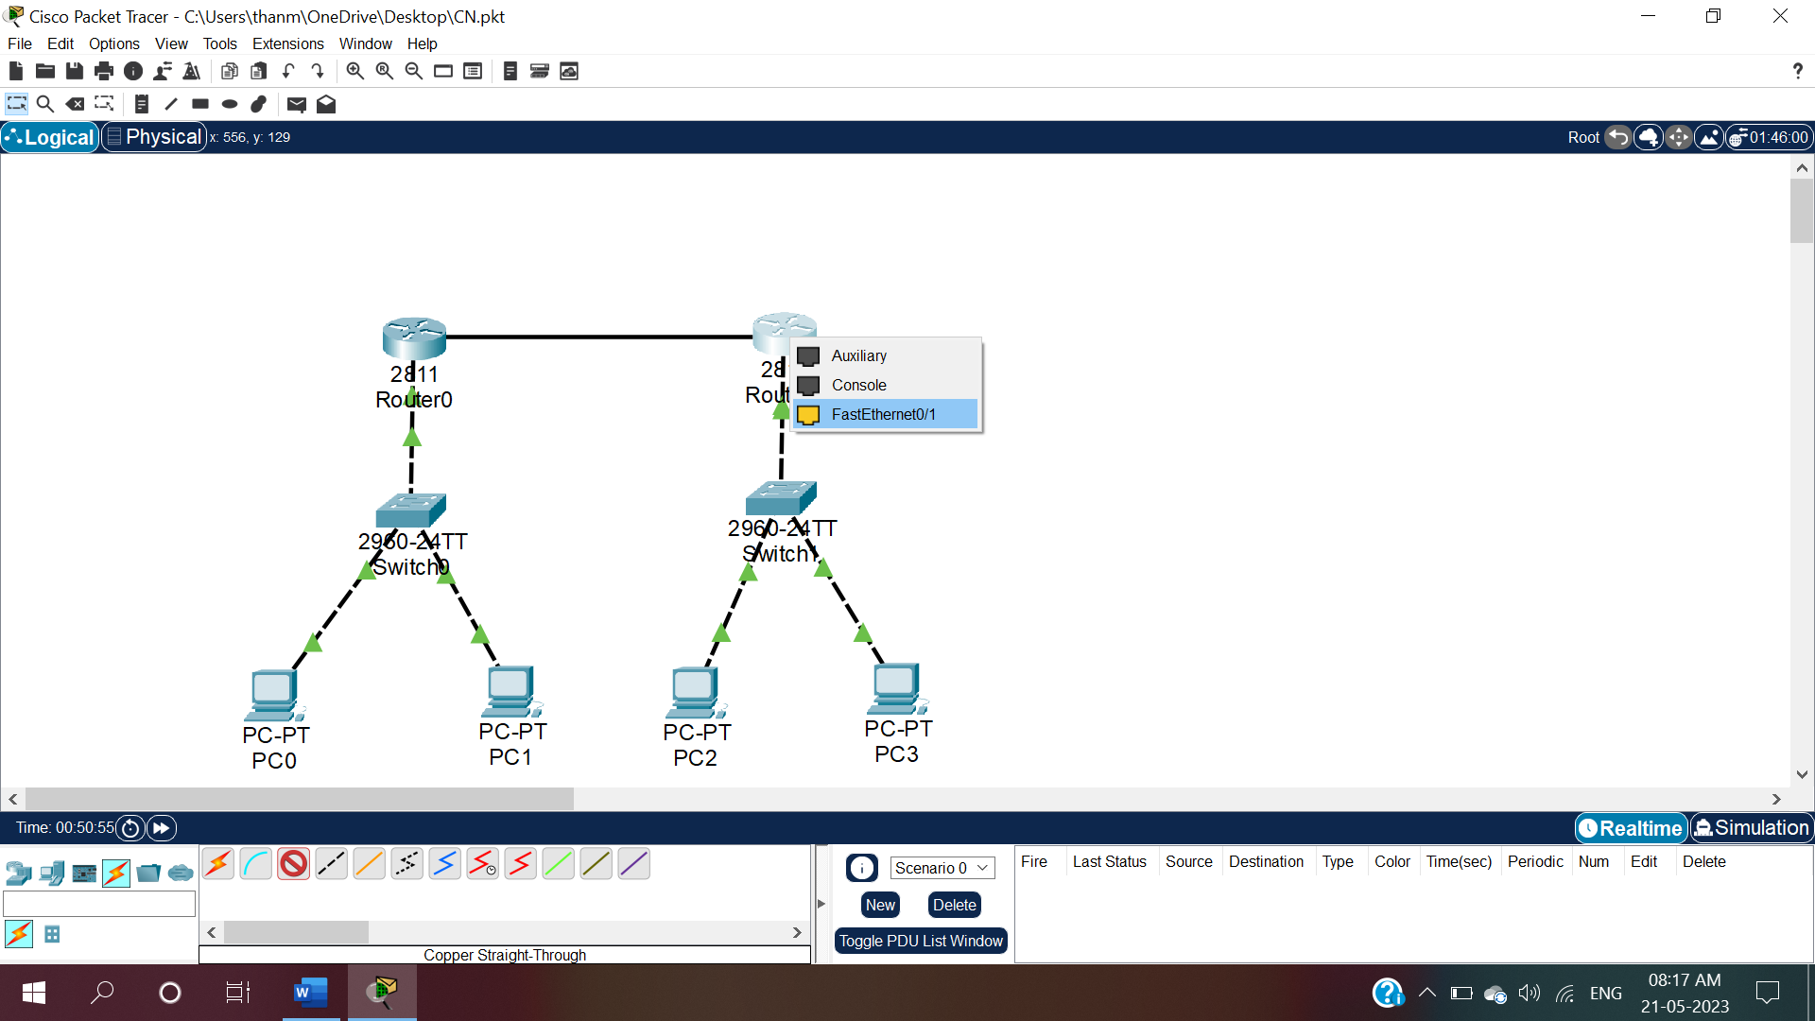

Fig.22:Drag the wire and click on Router1 and select FastEthernet0/1.

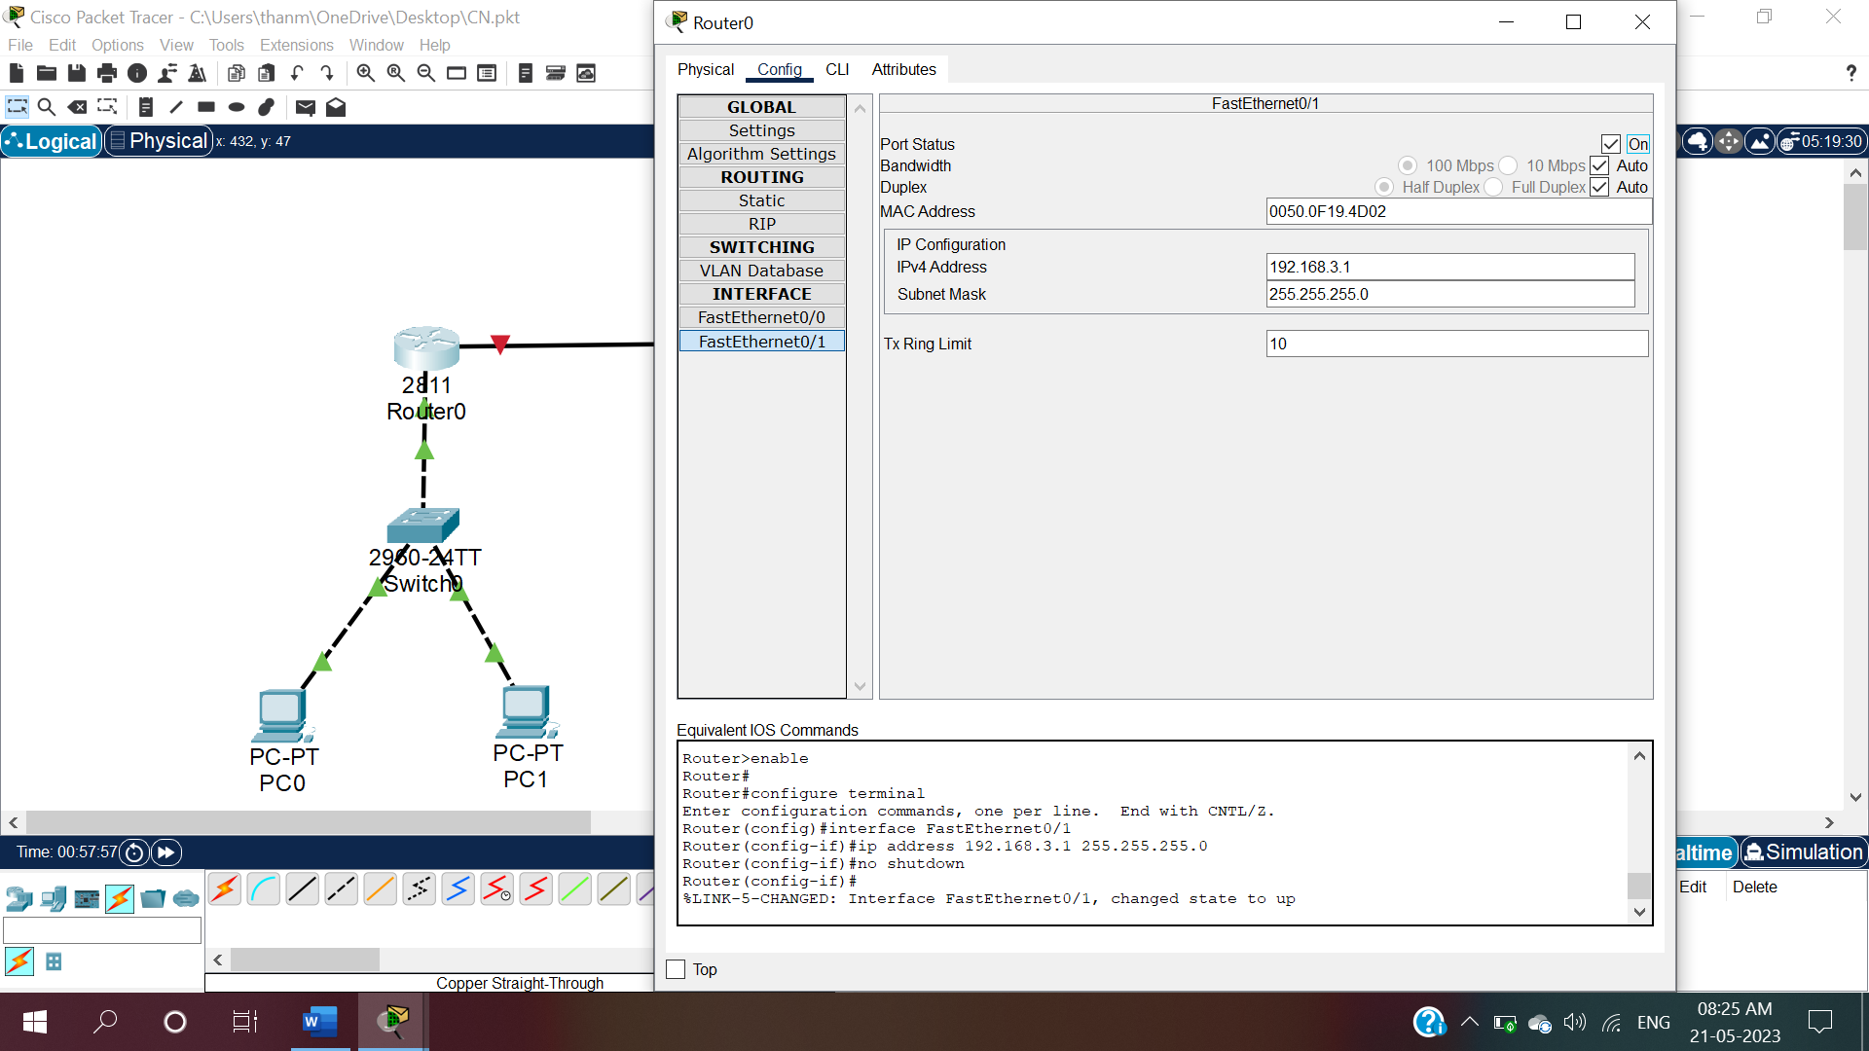

Fig.23:To move packets from Router0 to Router1, Click on Router0 and under config ,select FastEthernet0/1 and give IP Configuration as 192.168.3.1 and ON the Router0.

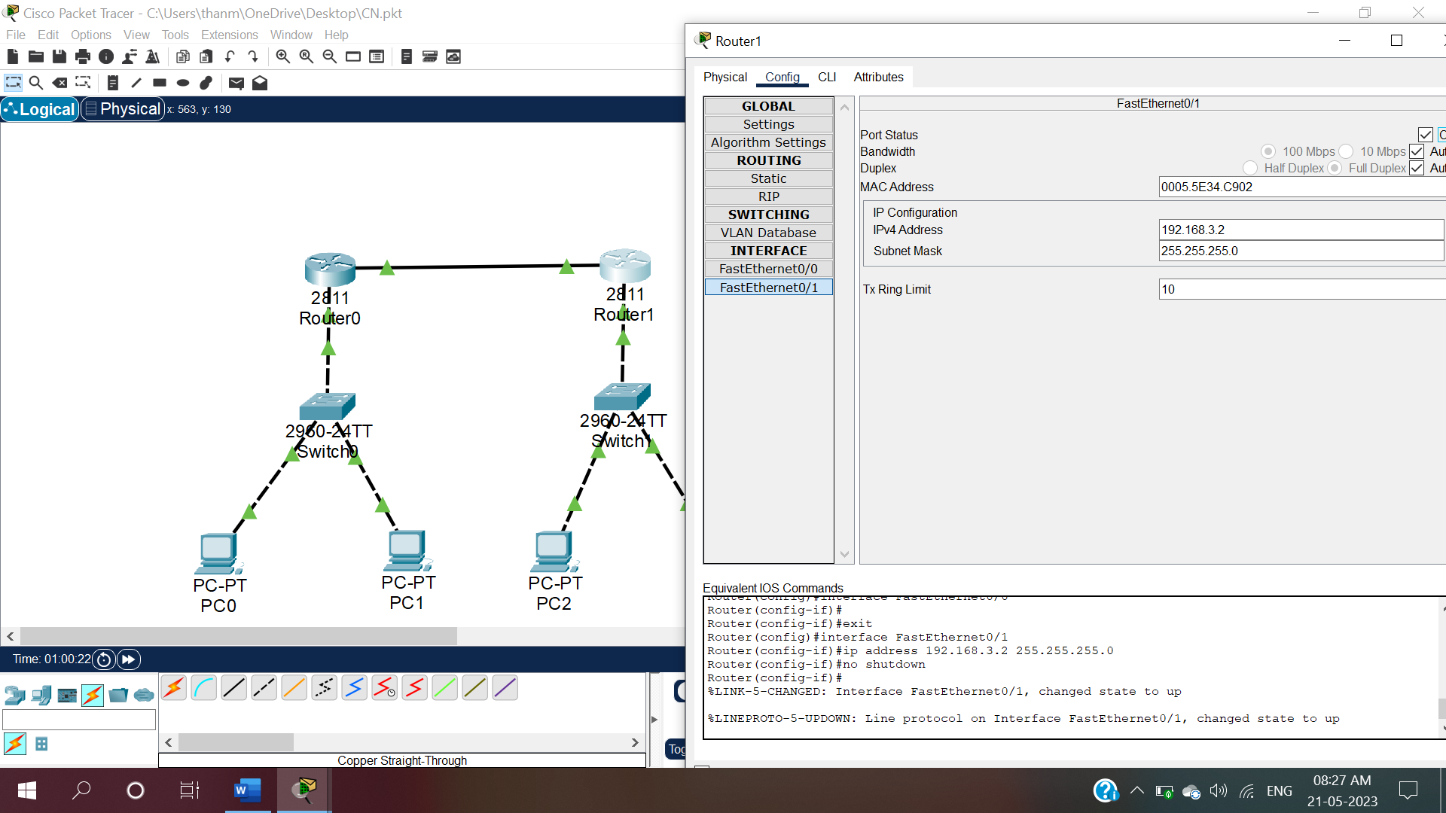

Fig.23.1: Click on Router1 and under config ,select FastEthernet0/1 and give IP Configuration as 192.168.3.2 and ON the Router1.

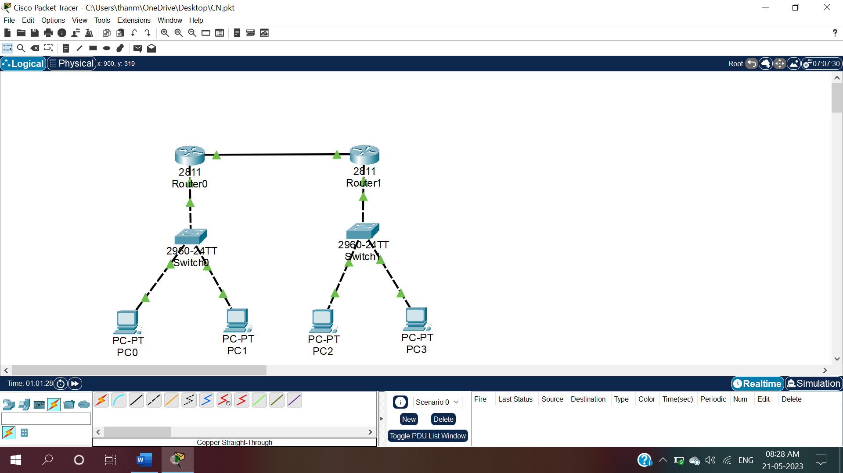

Fig.24:Now the connections and IP configurations are given to all the Routers, Switches and Pc’s

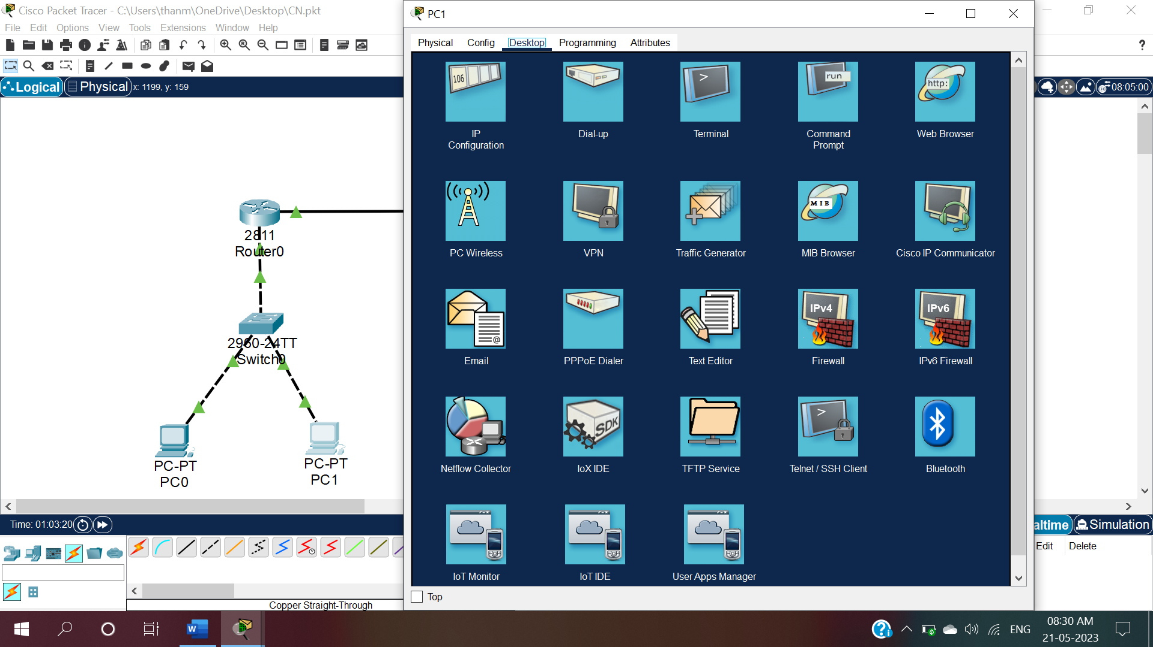

Fig.25:To check the connectivity, click on PC1 and under desktop select commandprompt.

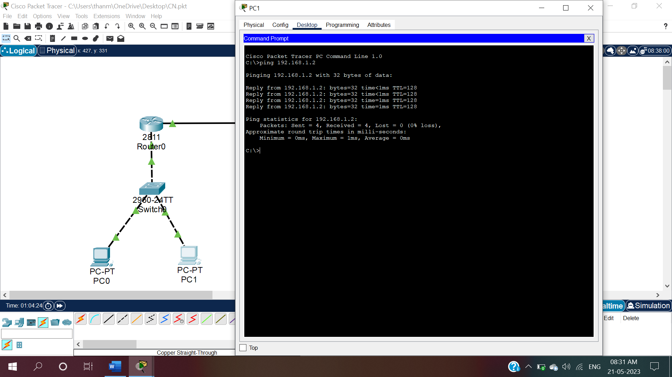

Fig.25.1:Open command prompt and type “ping 192.168.1.2”.It will give the ping statistics.

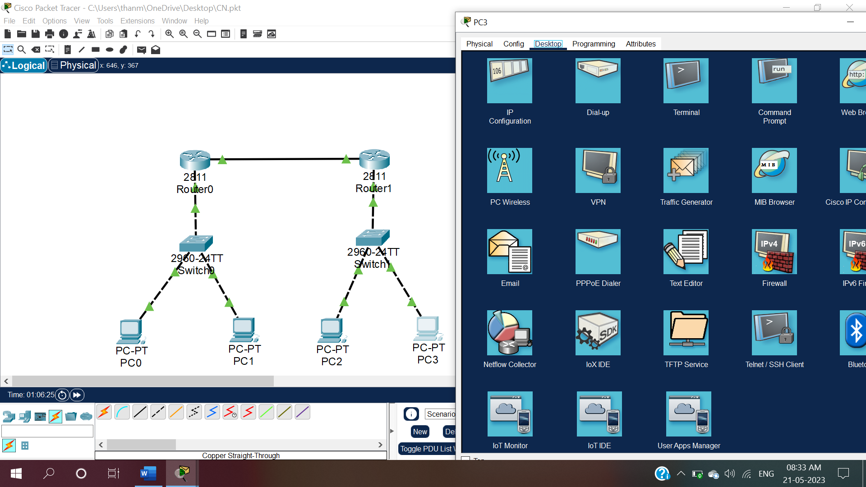

Fig.26:To check the connectivity, click on PC3 and under desktop select commandprompt.

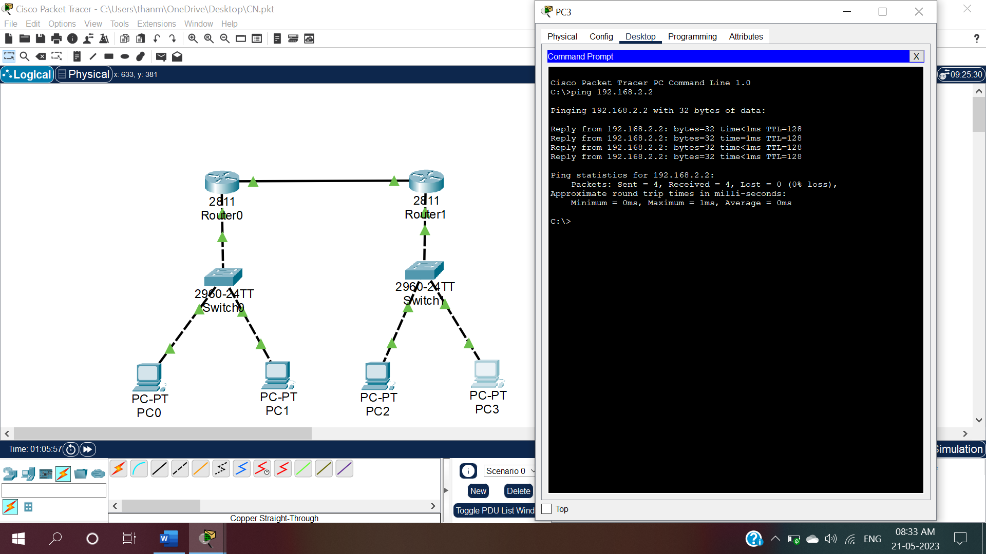

Fig.26.1:Open command prompt and type “ping 192.168.2.2”.It will give the ping statistics.

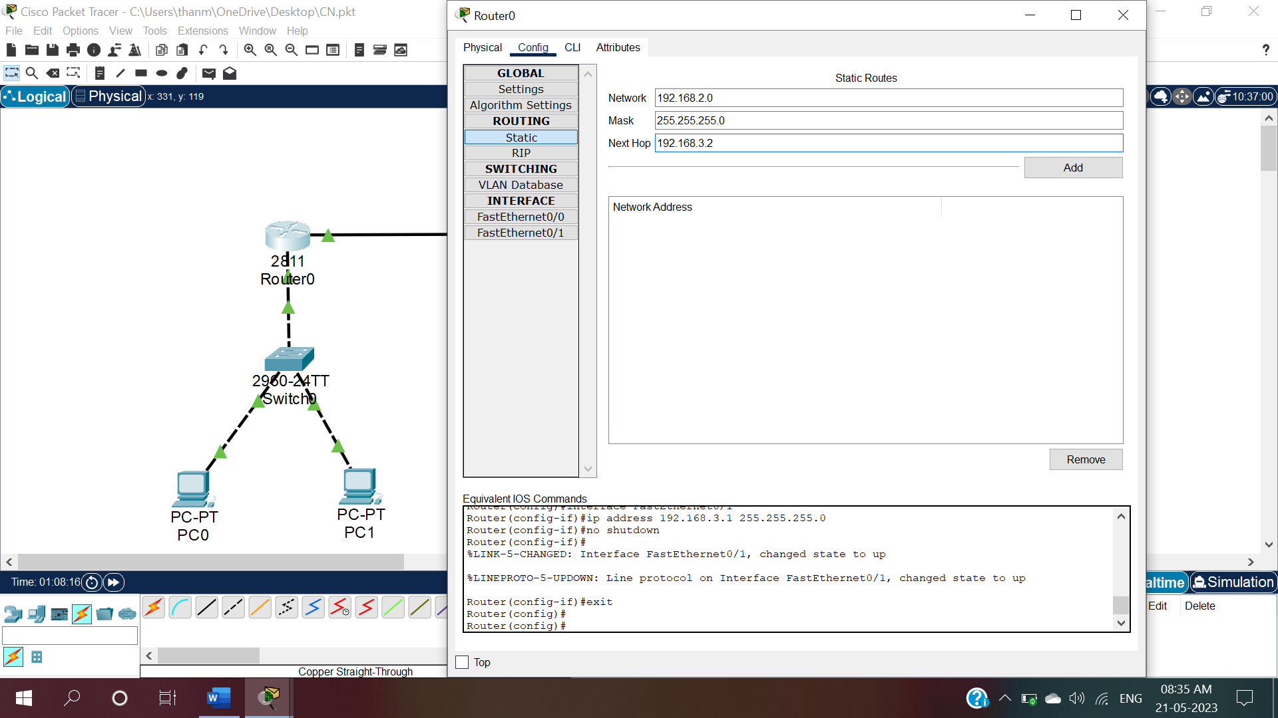

Fig.27:To make router (Router0) as static click on Router0 and under config click on static and give Network as “192.168.2.0” ,subnet as”255.255.255.0”,nexthop as “192.168.3.2”.

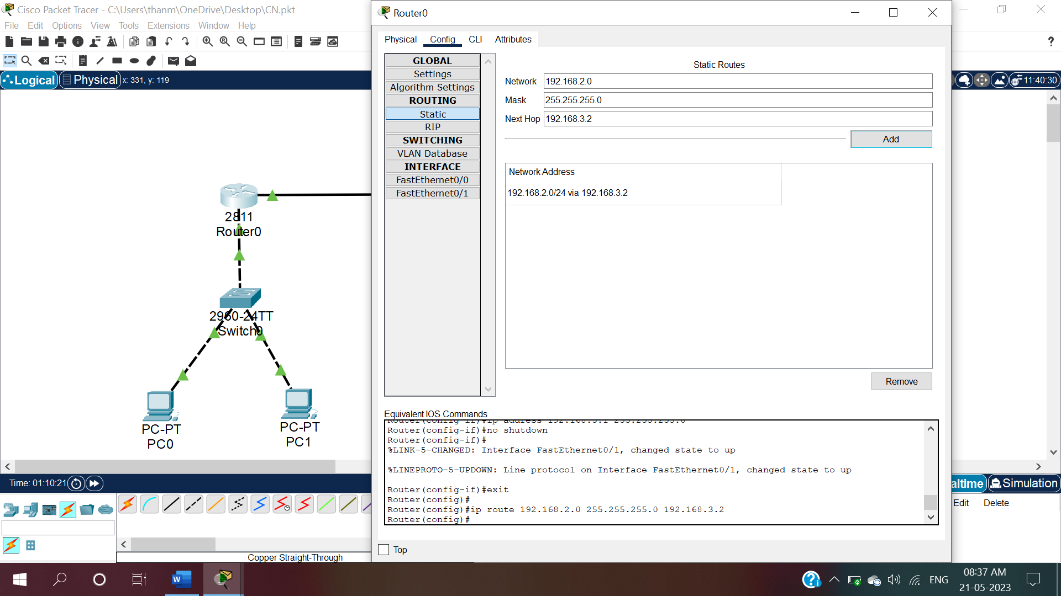

Fig.27.1:Click on add and the network address will be added.

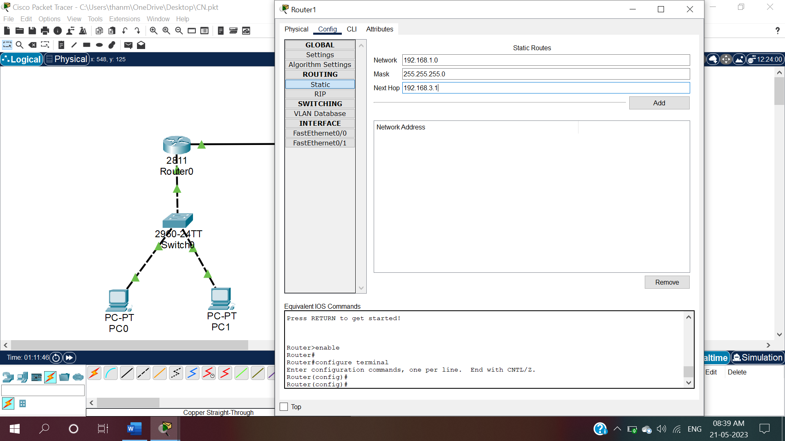

Fig.28:To make router (Router1) as static click on Router1 and under config click on static and give Network as “192.168.1.0” ,subnet as”255.255.255.0”,nexthop as “192.168.3.1”.

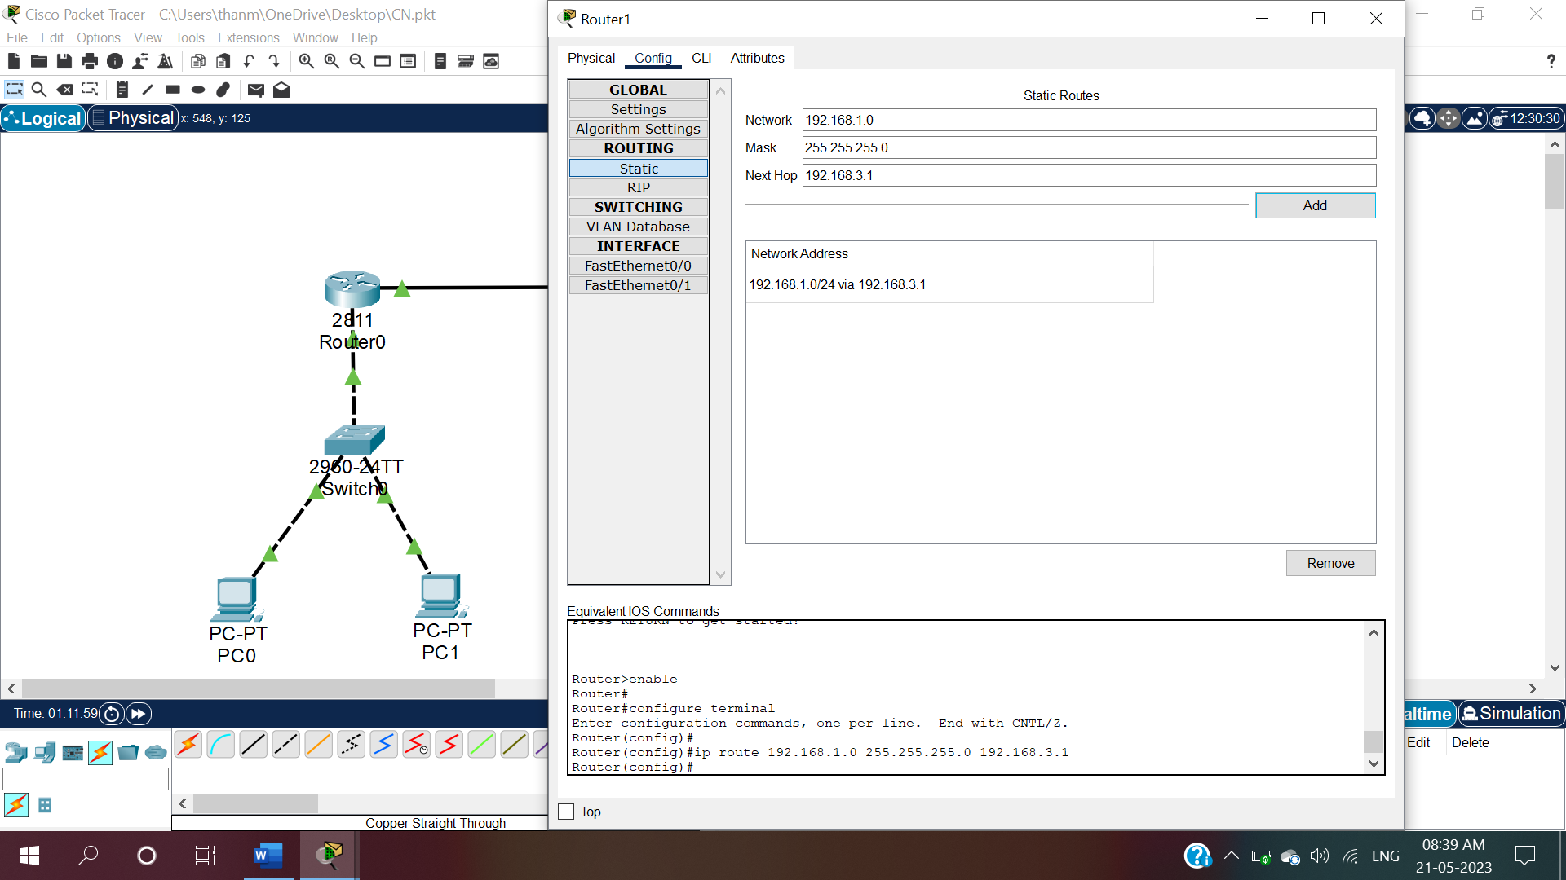

Fig.27.1:Click on add and the network address will be added.

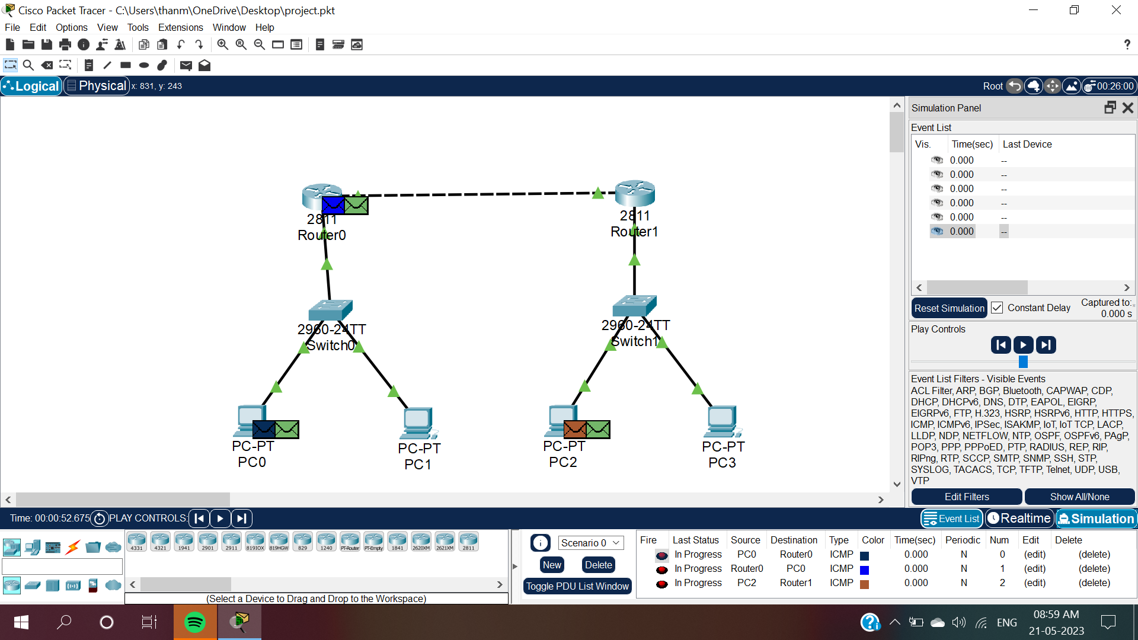

Fig.28:Click on packet symbol and click on PC0 to Router0, Router0 to PC0 and PC2 to Router1 (i.e., packets moves from given source to destinations).

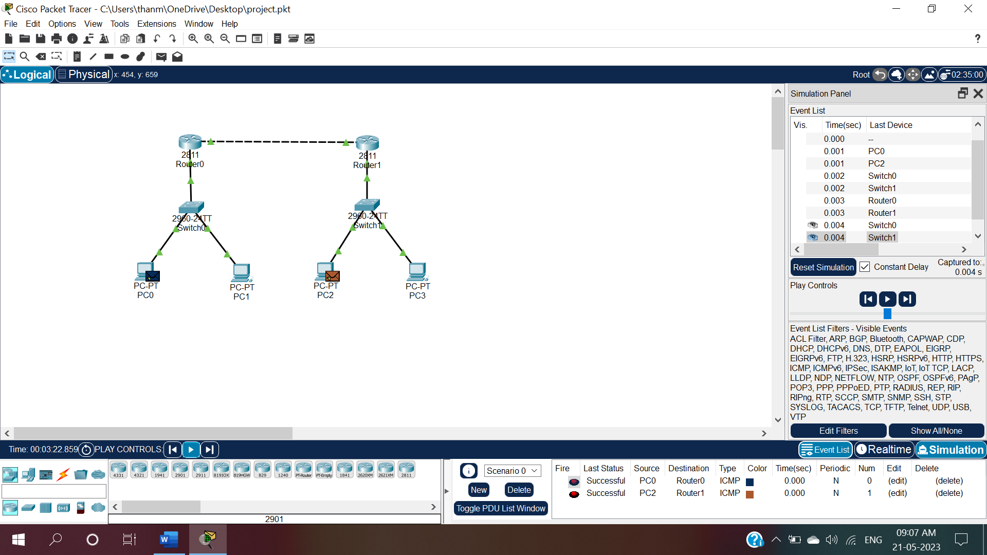

Fig.29:Click on play button,the packets starts transmitting and at bottom right of page the statistics will be displayed whether the packet transmission is successful or not.

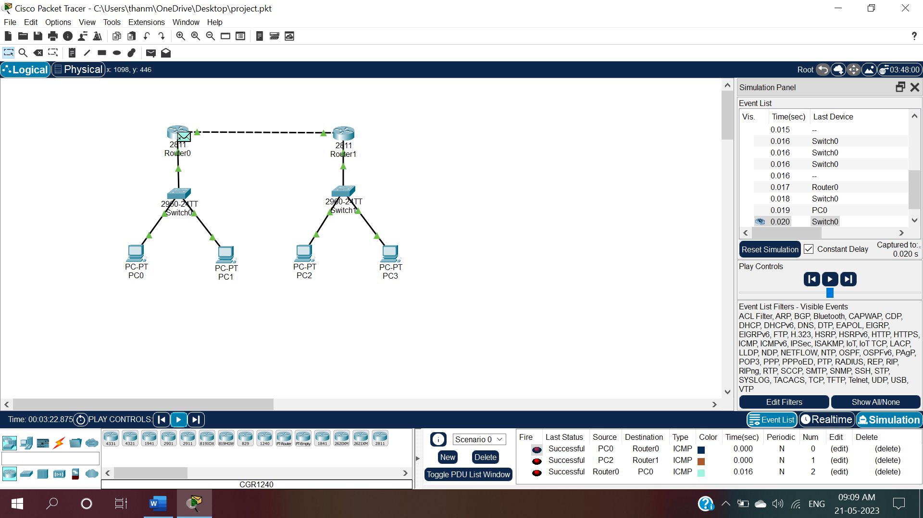

Fig.30:Packet Successfully transmitted from Router0 to PC0 .